Software Product Specification (SPS) for Care Data Exchange Support Documentation

Document Version: 2.1 (CDE Release version 2.1)
Version Released: 7/30/02

Prepared or Released by: CDE Development Team
For: CDE Support Team

Software Product Specification (SPS) General Overview

- Purpose – The purpose of this document is to provide first line support for the CDE product.

- Primary Authors– Authors are as follows

- Gui , Consumer site – Mark Flood

- ICS – Murali Nanchala,

- ILS – Arlan Pope

- Admin & Monitoring – Feijian Sun

Table of Contents
1. Scope 4
1.1 Identification 4
1.2 Required Software 4
1.3 System Overview 4
1.3.1 GUI – 4
1.3.2 Administration Console – 4
1.3.3 ICS – 5
1.3.4 ILS – 6
2. Reference Documents 7
3. Executable Software 8
3.1 GUI 8
3.2 Administration Console 8
3.3 ICS 8
3.4 ILS 8
4. Software Support Information 9
4.1 GUI – 9
4.1.1 CDE Process (High level summary) 9
4.1.2 Header Frame (Consumer and Clinician) 9
4.1.3 Privacy Policy (Consumer and Clinician) 9
4.1.4 Contact Us (Consumer and Clinician) 10
4.1.5 Login (Consumer and Clinician) 11
4.1.6 Welcome Bar (Consumer and Clinician) 13
4.1.7 Find Patient (Clinician Only) 14
4.1.8 Session Timeout Warning (Consumer and Clinician) 16
4.1.9 Consent Dialog (Clinician Only) 16
4.1.10 Patient Candidates (Clinician Only) 18
4.1.11 Major Dependencies 37
4.2 Administration Console – 39
4.2.1 Header Frame 39
4.2.2 Privacy Policy 39
4.2.3 Contact Us 41
4.2.4 Login 41
4.2.5 Index 42
4.2.6 Session Timeout Warning 43
4.2.7 FolderTreeLeftFrame 43
4.2.8 DisplayLogs 43
4.2.9 UDDIBrowse 44
4.2.10 Major Dependencies 45
4.3 ICS – 46
4.3.1 Properties file setup – 46
4.3.2 Multiple Patient Search 47
4.3.3 PatientListMediator 47
4.3.4 Create Single Virtual Admin User in LDAP 53
4.3.5 LDAP Configuration for Access (ACI) 54
4.3.6 ICS Event Logging 55
4.4 ILS – Installation Instruction 57
4.4.1 - under directory ‘apache-tomcat’ 58
4.4.2 Summary of Setup Files That Need to Be Customized 58
4.4.3 Properties Files Setup – 59
4.4.4 IlsLauncher.bat 66
4.4.5 How to setup tomcat to work with other application servers 66
4.4.6 Integration Options 66
4.4.7 Automated Polling 70
4.5 Certificates 75
4.6 SSL/HTTPS in CDE 75
4.7 Weblogic CDE Default Settings 76
4.8 Compilation/Build & Start/Stop Procedures 79
4.8.1 Startup/Stop Procedures for ICS 79
4.8.2 Startup / Stop Procedures for ILS 79
4.8.3 Build Procedures for CDE 79
5. Known Exceptions 80
5.1 GUI – 80
5.2 ICS – 80
5.3 Clinical Terminology Mapping 82
5.4 ILS – 82
5.5 Certs – 84
5.6 Misc – 85

Scope | Author | Reviewer
Information provided in this document is meant as first line support for existing and new CDE Clients. Documentation is provided by CDE 2.1 developers.

Identification | Author | Reviewer
This Care Data Exchange Support Documentation is to be used to support CDE release number 2.1.

1.2 Required Software | Author | Reviewer

Java 1.3 or higher

Jini 1.1 or higher

Tomcat 4.0 or other web servers (need to be tested)

Apache Axis (SOAP) server

Intelligent Search (JistXXX classes for ICS)

Weblogic 6.1 w/SP-2

Oracle 9.0.1

System Overview | Author | Reviewer

GUI –
The GUI is formed of JSP pages. It takes the user to search for a patient with the ICS (Identity Correlation Service) and then to find the patient’s data through ILS (Information Locator Service).

Currently, there are two versions of CDE GUI. There is a shortened version called CDE_ADMIN. This was developed for administrators to change the patient’s flag update. A separate set of JSPs were developed due to the original design of the CDE GUI.

All related GUI pages are registered in the WebLogic Application Server.

Administration Console –
The purpose of the Administration and Monitoring Console allows the systems administrator to execute tasks locally.

The properties file named, Admin.Properties, holds the properties for the SQL statement and database connection for the DBBean.java

This document details each screen included in the CDE Administration and Monitoring user interface. For each screen, the purpose and available user actions are described. In addition, all non-image files associated with the screen are listed and described.

ICS –
ICS - ICS or Identity Correlation Service is responsible for correlating the data coming into the Care Data Exchange (CDE). Correlating the data helps us to easily locate a particular Person’s record based on their demographic data, referred to as attributes. These attributes could be as few as one, an SSN to as many as the combination of a Name, Address, Gender, Date of Birth and SSN.

The ICS offers two services to the CDE. They are Person Identity Service or PIDS and Identity Service or IDS. These services are a one-to-one representation of the HL7’s ADT and QBP modules respectively and conform to the HL7 specification. The PIDS serves the ADT Add, Update, Merge and Delete requests. The IDS serves the QBP Find Candidates and Get Profile requests. Both PIDS and IDS are RMI services.

All the PIDS services take in Person Objects as a parameter and return a Boolean value as the acknowledgement. In IDS services, Find Candidates returns a List of Person Objects, which are correlated to be similar to that of the input Object. Get Profile returns a single Person Object, which the Correlation System deems as an exact match for the input Object. For CDE 2.0, the getProfile method no longer returns a single Person object. It now returns a list of Person objects the Correlation System deems are a match for the input identifier. In addition, a new method, getProfileList, has been added to the Identity Service. It retrieves a list of lists of Person objects associated with each identifier in a list. Correct, a list of lists.

Both the PIDS and IDS are registered in the WebLogic Application Server and are invoked as start-up services during WebLogic Server start-up.

Both PIDS and IDS benefit from performance improvements to com.carescience.db.objectivity.DatabaseServicesObjy, which originally created a new DatabaseServicesObjy for each call to the database. This was computationally expensive - each call re-established a connection to the same Objectivity DB and rebuilt the attribute map.

Multiple Patient Search

The IdentityService interface for CDE 2.0 has a new method

List getProfileList(List identifiers) throws RemoteException, IdentityServiceException;

This method takes in a list of PersonIdentifier Objects and searches the database for their corresponding Person Objects.

In the implementation, viz., in IdentityServiceImpl Class, all it does is iterate through the list of input PersonIdentifier Objects and call the getProfile() method of the IdentityService for each. It then collects the returned Person Objects into a list and returns them as output.

NOTE: There is no particular ordering of the Person Objects returned from this method of the IdentityService service. Since the UI send an ArrayList of PersonIdentifiers and since the IdentityService iterates through these identifiers, they can be expected to be in the same order as that of the incoming requests.

PatientListMediator

ICS now has a new interface called PatientListMediator, which enables a user to temporarily persist a patient search history list in a Lightweight Directory Access Protocol (LDAP) server.

Users will be able to persist their search history list in their respective directories in LDAP. This is achieved by passing the user’s login credentials from their certificate by the UI to the PatientListMediator service.

TECH SERVICES NOTE: This service needs to be started with the underlying (web/App) Server at Server startup. In this case WebLogic.

TECH SERVICES NOTE: The URL to the LDAP Server and the port on which it runs needs to be mentioned in the CDE.properties file.

This is an addition to CDE from v2.0 onwards.

ILS –
ILS or Information Locator Service is responsible for facilitating searches or queries for clinical data of a specific person or patient. ILS is simply the mechanism for performing these searches, which takes place across the Internet.

ILS receives the request from the CDE front end (GUI). The request is comprised of 7 parameters: PatientId, ProviderId, EncounterId, Type, Class, StartDate and EndDate. ILS then “locates” where the data is by extracting the Assigning Facility’s NameSpace Id from the Person Identifier. The request is then sent to ILS running at that domain. This ILS node performs the search on the organizations Data Repository and sends back the response.

Reference Documents | Author | Reviewer
See
P:\Product Development\CareScience Technical Documents\CDE Tech Docs

ILS
CDE_Locator_InterfaceSpec_1.1.0.pdf
\\Honeycutt\share\Product Development\CareScience Technical Documents\Released Documents (.pdf)\CDE\CDE Interface Spec\LS\CDE_Locator_IntfcSpec_1.1.0.pdf

CDE1.2_ILS_Spec(EDI-XML).pdf
\\Honeycutt\share\Product Development\CareScience Technical Documents\Released Documents (.pdf)\CDE\CDE Interface Spec\LS\CDE1.2_ILS_Spec(EDI-XML).pdf

CDE1.2_ILSSpec.pdf
\\Honeycutt\share\Product Development\CareScience Technical Documents\Released Documents (.pdf)\CDE\CDE Interface Spec\LS\CDE1.2_ILSSpec.pdf

ICS
CDE1.2_ICS_Spec(EDI).pdf
\\Honeycutt\share\Product Development\CareScience Technical Documents\Released Documents (.pdf)\CDE\CDE Interface Spec\UCS\CDE1.2_ICS_Spec(EDI).pdf

CDE1.2_ICS_Spec(XML).pdf
\\Honeycutt\share\Product Development\CareScience Technical Documents\Released Documents (.pdf)\CDE\CDE Interface Spec\UCS\CDE1.2_ICS_Spec(XML).pdf

.

Executable Software | Author | Reviewer

GUI
QA environment url - https://weblogic02.carescience.com/
Test environment url – https://testcde.carescience.com/

Administration Console
QA environment - http://weblogic02/cde/AdminMonitoring/index.html

ICS

Since all the services in ICS are startup services of the underlying WebLogic Application Server, they startup and shutdown with the WebLogic Application Server.

ILS
ILS is started using the admin tool. To run the admin tool, execute …\CareScience\bin\ilslauncher.bat

Software Support Information | Author | Reviewer

GUI –
On weblogic02, all files are under /bea/wlserver6.1/config/mydomain/applications/cde.

CDE Process (High level summary)
- Use LDAP and Certificates to authenticate users. (Login.jsp)
- Log logins and logouts. (UiLogger.java)
- Accept user’s patient search information. (PatientSearch.jsp)
- Gets search results from ICS, via RMI. (LocatePatient.jsp)
- Display patient search results. (PatientResults.jsp)
- Acquire user’s consent to view patients’ information (ConsentDialog.jsp)
- Logs user’s consent response (UILogger.java)
- Accept user’s class, type, and date search parameters (ResultTypesFrames.jsp)
- Use CDELocatorAdaptor class to send the search criteria to the JiniServices. Locator Adaptor returns results in an XML document. (LocateData.jsp)
- Show user status of search while waiting. (WaitMsgLocateData.jsp)
- Transform search results from XML to HTML and display to user (PatientDataResults.jsp)
- Allow user to click on the results URLs and display the data received from external facility (ViewResultsFrm.jsp).

Header Frame (Consumer and Clinician)
Purpose
The Header Frame is at the top of every page in the application. It provides access to functions that should always be available.

User Actions
- Privacy Policy: Displays the static CareScience privacy policy in a separate window. (see below)
- Contact Us: Displays the static CareScience contact information for the CDE product in a separate window. (see below)
- CareScience: Displays the CareScience homepage in the current window.

Files
- index.html: This is the main FrameSet for the entire application. The first frame is the header, and the second frame is where all the remaining pages reside.
- CareScienceHeader.html: This is the actual header file.
- incOpenWin.js: This file contains the JavaScript code that handle the creation of a separate window.
- cde.css: This is the Cascading Style Sheet used by all the visible pages in the application.

Privacy Policy (Consumer and Clinician)
Purpose
This page displays CareScience’s privacy policy.
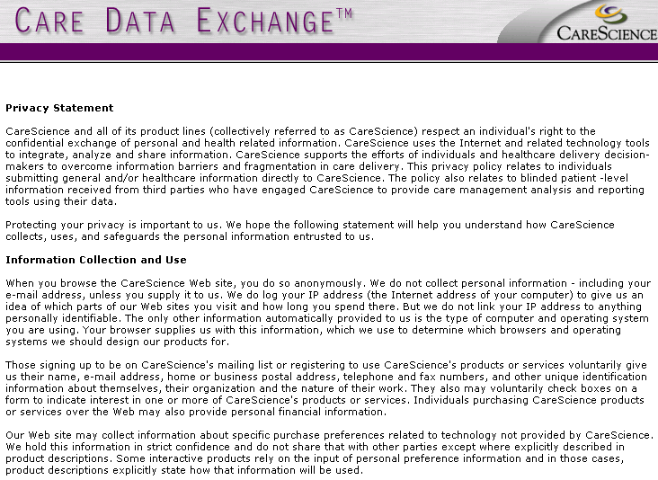

User Actions
- None

Files
- cde_privacy_policy.html: static page
- cde.css: This is the Cascading Style Sheet used by all the visible pages in the application.

Contact Us (Consumer and Clinician)

Purpose
This page displays CareScience contact information for the CDE application.
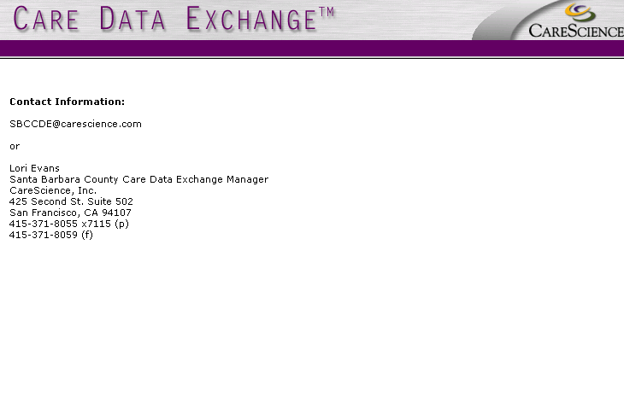

User Actions
- None

Files
- cde_contact_info.html: static page
- cde.css: This is the Cascading Style Sheet used by all the visible pages in the application.

Login (Consumer and Clinician)
Purpose

This page allows the user to login to the application. The user must have already selected a suitable certification for the session.

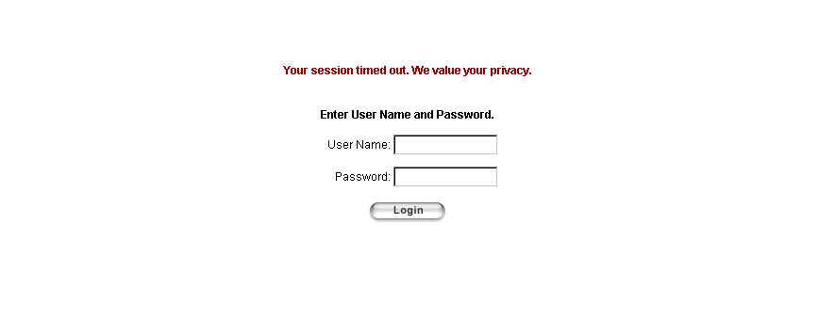

User Actions
- Login: Authenticates the User Name and Password. If the User Name/Password are correct, the user is logged in and taken to the Find Patient screen. Otherwise, an alert box with an error message is displayed.

Files
- login.jsp: Handles the display as well as the processing. Tries to authenticate the user and if succesful, writes an entry to the log and fills some session variables. Also logs when the user times out.
- handleSecurityError.html: Displays an error message when the login page determines that there is no certificate. I was not able to duplicate the conditions that cause this page to display.
- no_cache.jsp: Sets the page so that it will be reloaded each time it is requested (and not just served from local cache).
- browser_info.jsp: Determines the browser type and version that the user is using and stores the results in the session object.
- incBrowserType.js: Determines the browser type and version that the user is using to support the browser_update.jsp functionality.
- browser_update.jsp: Alerts the user if he is using an unsupported browser and offers links to acquire a supported browser version.
- error_handler.jsp: The default error page for the application – displays the error message in a more friendly format
- style_sheet.jsp: Contains style sheet entries – used by error_handler.jsp and browser_update.jsp, not login.jsp
- incResize.js: Refreshes the page to handle the Netscape resizing problem.
- com.carescience.http.Http: Encodes the username for proper HTML display
- com.protomatter.syslog.Syslog: Sends messages to the console
- com.carescience.cde.ui.UiLogger: Logs to the DB when a user times out and logs in
- com.carescience.security.ldap.LDAPUtil: Manipulates the certification
- com.carescience.security.ldap.LDAPAuthenticate: Handles the authentication of the User Name/Password
- cde.css: This is the Cascading Style Sheet used by all the visible pages in the application.

Welcome Bar (Consumer and Clinician)
Purpose
The Welcome Bar appears at the top of all main-window pages, except for the login screen. It displays the user’s common name from the certificate and provides access to functions that should always be available. It also allows the user to access and return from the Administration page. Note that in addition to the Consumer User Differences detailed below, on the Consent Dialog page, there are no links, only the welcome message. This is to enforce the modality of that page.

User Actions
- Help: Calls the help application.
- Change Password: Calls an LDAP function that allows the user to change his password. Note that all Change Password behavior is external to CDE. Once the link is selected the LDAP server controls everything that follows.
- Log Out: Logs out the user and takes him to the Login page (above).

Files
- WelcomeHelpLogout.jsp: This is the file that produces the display. It is included at the top of each visible jsp page.
- com.carescience.utilities.CSProperties: Utility file that provides access to the CDE.properties file. This file contains the URL to access the LDAP Change Password screen.

Consumer User Differences
In addition to the basic functionality, the welcome bar also serves as the main navigation device for Consumers. There are 3 unrelated areas of functionality in the Consumer application: Demography, Results and Consent Logs. Depending on where the Consumer is, links will appear in the welcome bar for the other 2 functions.

- My Demography: Returns the user to the My Demography page, where he can view his aliases and update his notes
- My Results: Takes the user to the Locate My Results page, where he can enter search parameters and then view results
- Consent Logs: Takes the user to the Consent Logs page, where he can view users who have stated consent to view his information.

Find Patient (Clinician Only)

Purpose
The Find Patient screen allows the user to locate a given patient in one of 3 ways. If the user knows the ID of the patient, he can enter the ID and get the patient’s profile. If the user knows some demographic data about the patient, he can search on that data and generate a list of potential candidates. Finally, if the user has successfully searched on that patient before and chosen to add that patient to a Patient List, he can locate and select the patient from the list.

If the user has chosen a Polling interval for the selected patient list, that interval will be displayed and any new results that have been polled since the user last logged in will display in the column next to the patient’s name.

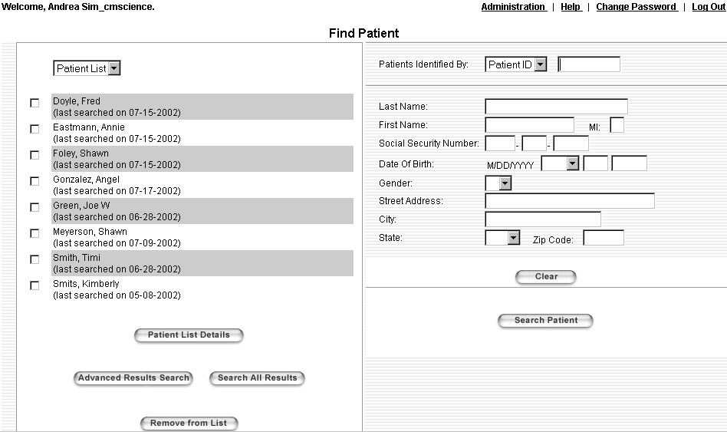
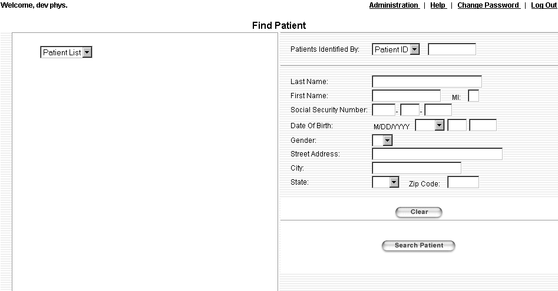

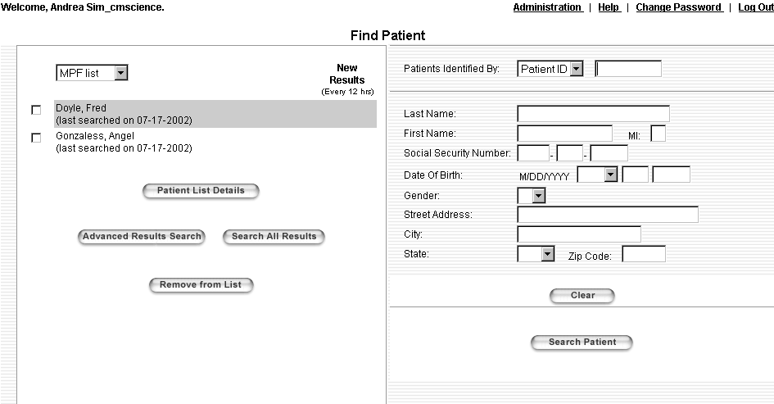

User Actions
- Patient List Details: If a Patient is available in the list, displays details for all selected patients in the Patient Candidates page. Users may only select up to 5 patients.
- Advanced Results Search: If a Patient is available in the list, displays the Locate Results screen with those patients selected. If even one of the patients has not yet been selected in this session, the Consent Dialog box will first display (below). Users may only select up to 5 patients.
- Search All Results: If a Patient is available in the list, displays results for all Data Types and Classes for those patients selected. If even one of the patients has not yet been selected in this session, the Consent Dialog box will first display (below). Users may only select up to 5 patients.
- Remove Patient From List (minus sign buttons): Removes a patient from the Patient List. There is one of these buttons for each patient in the Patient List.
- Clear: Clears all user-entered data from the right half of the page (Patient ID and Candidate Data).
- Search Patient: Collects all data from the right half of the screen and sends them to the ICS. Either an error message or the Patient Candidates page will be displayed.
- Currently the Patient List and Patient ID drop-down list boxes each contain only 1 hard-coded value. The user cannot change these.

Files
- PatientSearch.jsp: Gets the Patient List value (currently only 1) and if none exists (as would happen when the user logs in for the first time) creates one called ‘Patient List’. Displays all patients for the selected Patient List and allows the user to interact with the list. Allows the user to enter patient demographics or and ID and perform a search. Kicks off the logic to determine if the Consent Dialog needs to be displayed and displays it if needed.
- browser_info.jsp: Determines the browser type and version that the user is using and stores the results in the session object.
- no_cache.jsp: Sets the page so that it will be reloaded each time it is requested (and not just served from local cache).
- SessionTimeoutWarning.jsp: Non-viewable Java and JavaScript code that warns the user that his session is about to expire. (below)
- WelcomeHelpLogout.jsp: Displays the Welcome Bar (above).
- ValidSessionChkTop.jsp: Logic included at the top of each visible page that checks to see if the user session has timed out and if so, forwards to the Login page.
- ValidSessionChkBottom.jsp: Logic included at the bottom of each visible page that completes the block started in ValidSessionChkTop.jsp. Also has a CATCH block that forwards to the error page if and exception is thrown while processing the page.
- PatientSearch.js: Contains the JavaScript for this page, including the button action methods
- PatientSearchValidation.js: Contains the JavaScript that determines if the user-entered input is correctly formatted. This was just broken out from PatientSearch.js for maintainability.
- incBrowserType.js: Determines the browser type and version that the user is using to support the Consent Dialog functionality.
- incResize.js: Refreshes the page to handle the Netscape resizing problem.
- com.carescience.cde.ui.WebKeys: Contains the keys to retrieve the JavaBeans from the session.
- com.carescience.cde.ui.PatientSearchMainBean: Provides getter and setter method for all screen-level fields as well as some supporting methods.
- com.carescience.data.Person: Used to create the list of selected Persons, once they are found from the Patient List. This list is then passed downstream to the other pages.
- com.carescience.cde.ui.PatientListWebImpl: Contains all the logic to access the back-end LDAP services that maintain the Patient Lists. Patient Lists and Patient List Entries can be added, read and removed.
- StateAbbrev.jsp: Include file that contains the HTML to produce the State drop-down list box.
- cde.css: This is the Cascading Style Sheet used by all the visible pages in the application.

Session Timeout Warning (Consumer and Clinician)
Purpose
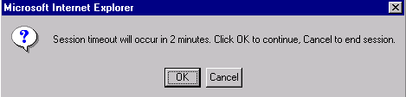
For security reasons, the user session is set to expire after a certain period of inactivity. This feature warns the user at a preset period of time before the session is set to expire. The user is given the opportunity to repost the current page, which resets the session timeout clock.

User Actions
- OK: Reposts the current page, resetting the session timeout clock. The user will see the page flash as the page posts and any changes to values on that screen will be lost.
- Cancel: Logs the user out and takes him to the Login screen

Files
- SessionTimeoutWarning.jsp: Non-viewable page that created the JavaScript needed to support this feature. The viewable page still needs to setup the correct script for the onLoad event to enable this feature.
- incUtil.js: Various JavaScript utilities, including one to change the current page contents.
- login.jsp: This is the file in which the timeout period is set in the session object.

Consent Dialog (Clinician Only)
Purpose
The first time within a session that a user selects a patient and chooses to continue to search for results on that patient, the user must confirm that he has consent to view the patient’s medical information. The user makes this confirmation by answering affirmatively to the Consent Dialog. The Consent Dialog appears whether a candidate is selected after an ID or demographic search. It also appears when the user selects a patient from the Patient List. Once consent has been confirmed, the Consent Dialog should not appear again within that session, regardless of whether the search is performed via the Patient List, demographic data or ID.

This information is logged to a database so that reports can be run against it. In addition, the information is stored so that it can be associated with the logging that occurs when a result is viewed.


User Actions
- Yes: Makes a log entry recording the Yes answer and lets the user proceed to whatever page he had selected (i.e. Advanced Results Search)
- No: Makes a log entry recording the No answer and returns the user to the Find Patient screen with all user-entered input cleared out.

Files
- ConsentDialog.jsp: Viewable page that first determines if consent has already been given. If so, directs the flow to the proper next page. If not, displays the question and then fields the responses. Based on the response, does the needed logging and again directs the flow to the proper next page.
- com.carescience.cde.ui.PatientListWebImpl: Contains all the logic to access the back-end LDAP services that maintain the Patient Lists. Patients are added to the list right after consent is confirmed (either by the user, or by a check that the patient has already been confirmed in this session)
- browser_info.jsp: Determines the browser type and version that the user is using and stores the results in the session object.
- no_cache.jsp: Sets the page so that it will be reloaded each time it is requested (and not just served from local cache).
- ValidSessionChkTop.jsp: Logic included at the top of each visible page that checks to see if the user session has timed out and if so, forwards to the Login page.
- ValidSessionChkBottom.jsp: Logic included at the bottom of each visible page that completes the block started in ValidSessionChkTop.jsp. Also has a CATCH block that forwards to the error page if and exception is thrown while processing the page.
- SessionTimeoutWarning.jsp: Non-viewable Java and JavaScript code that warns the user that his session is about to expire. (below)
- WelcomeHelpLogout.jsp: Displays the Welcome Bar (above). Note that only the welcome message is displayed on this page. The links are suppressed to enforce the modality of this page.
- incBrowserType.js: Determines the browser type and version that the user is using
- incResize.js: Refreshes the page to handle the Netscape resizing problem.
- ConsentDialog.js: Contains the JavaScript to handle the button actions, etc.
- com.carescience.cde.ui.ConsentDialogMainAccessor: Contains the routines that maintain the list of patients for whom consent has already been confirmed in that session. Also handles the actual writing to the logs and updates the session variable used by the result view logging routine.
- com.protomatter.syslog.Syslog: Sends messages to the console
- com.carescience.cde.ui.UiLogger: Logs to the DB when the user confirms or denies consent, and also when the user just closes the dialog box.
- com.carescience.cde.ui.WebKeys: List of constants used to access objects in the session object.
- com.carescience.data.Person: Used to log the patient whose results are being accessed.
- com.carescience.data.PersonName: Used to log the user name
- com.carescience.cde.ui.ConsentLog: contains all the information to be logged
- com.carescience.cde.ui.Utility: Contains a method that takes the Person object and the user-entered ID and returns the person ID that needs to be logged
- cde.css: This is the Cascading Style Sheet used by all the visible pages in the application.

Patient Candidates (Clinician Only)
Purpose

The Patient Candidates allows the user to see patient details, including aliases, if available. The user can then select any number of patients to do a results search. In addition, the user may control which patients are added to the Patient List. By default, patients will be added to the Patient List that is currently visible in the Patient Search screen; the user must select ‘None’ as the list choice for those patients that he does not wish to have added to the list. There are 6 different forms the Patient Candidates screen can take. LocatePatient.jsp does the patient lookup and based on the results determines which of the 4 major formats the screen will take. The remaining 2 formats are variations that include or exclude the Add to List checkbox; this is determined by the affected screens based on the how they were called.

No Results
If the user does a search by ID or demographics and there are no patient matches, he will receive this screen.


User Actions
- Refine Search: Returns the user to the Find Patient screen; all of the user-entered information is retained and displayed.
- New Patient Search: Returns the user to the Find Patient screen; all of the user-entered information is discarded.

Files
- LocatePatientNoResults.jsp: Displays the visual components

No Access
If the user does a search by ID or demographics and there are patient matches, but the user does not have the correct access permissions to view those patients, he will receive this screen.


User Actions
- Refine Search: Returns the user to the Find Patient screen; all of the user-entered information is retained and displayed.
- New Patient Search: Returns the user to the Find Patient screen; all of the user-entered information is discarded.

Files
- LocatePatientNoAccess.jsp: Displays the visual components

Single Patient – Candidate Search/Patient List Details
When the user does a search through any of the 3 methods that results in a single patient match (and the user has permissions to view this patient), he will receive this screen. Note that the Add to List DDLB is not visible when this screen is reached from via the Patient List Details button. In this case, there is no reason to not add the patient to the list, since the patient is already in the list, by definition. The last access date will be updated. Otherwise, the patient list that was displaying on the Patient Search screen is the default, but can be changed to any other list, or ‘None’. The selection of ‘None’ will restrict the patient from being added to any patient list.

The screen initially displays with the patient collapsed, but clicking on the arrow by the patient name expands the patient, causing any available aliases to by displayed (the gray rows). Similarly, the notes do not automatically display, but can be viewed by selecting the Notes icon. A Notes icon only appears next to patients that have a note. Viewing notes and aliases can be done independently or together.
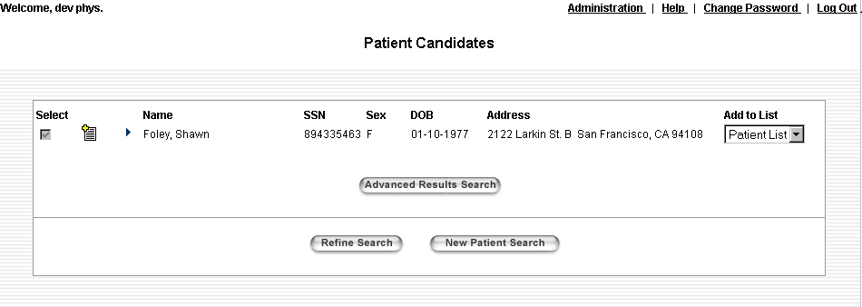
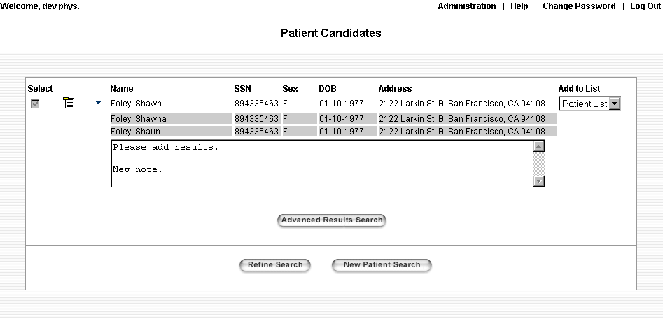

User Actions
- Right Arrow/Down arrow: Expands/collapses the aliases for a patient.
- Plus/Minus Document: Views/hides the read-only Note for the patient.
- Advanced Results Search: Displays the Locate Results screen for the patient. If the patient has not yet been selected in this session, the Consent Dialog box will first display (above).
- Refine Search: Returns the user to the Find Patient screen; all of the user-entered information is retained and displayed.
- New Patient Search: Returns the user to the Find Patient screen; all of the user-entered information is discarded.
- Update Note: Saves the note. This is available for Consumers only.

Files
- PatientResultsSingleHtm.jsp: Displays the visual components

Multiple Patients -- Candidate Search /Patient List Details
When the user does a search through any of the 3 methods that results in multiple patient matches (and the user has permissions to view these patients), he will receive this screen. Note that the Add to List DDLB is not visible when this screen is reached from via the Patient List Details button. In this case, there is no reason to not add patients to the list, since the patients are already in the list, by definition. The last access dates will be updated. Also, the Add to List DDLB is only enabled when the patient is Selected, at which point it will default to the list that is visible in the Patient Search screen. It can be changed to any other list, or ‘None’. The selection of ‘None’ will restrict the patient from being added to any patient list.

The screen initial displays with patients collapsed, but clicking on the arrow by a patient name expands the patient, causing any available aliases to by displayed (the gray rows). Similarly, the notes do not automatically display, but can be viewed by selecting the Notes icon. A Notes icon only appears next to patients that have a note. Viewing notes and aliases can be done independently or together.
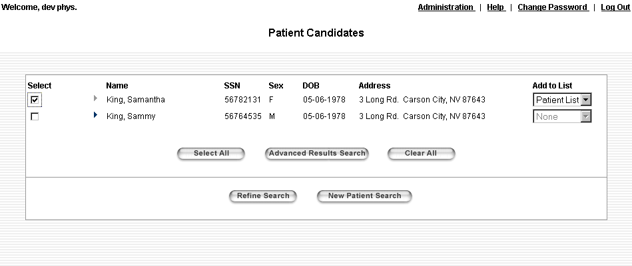

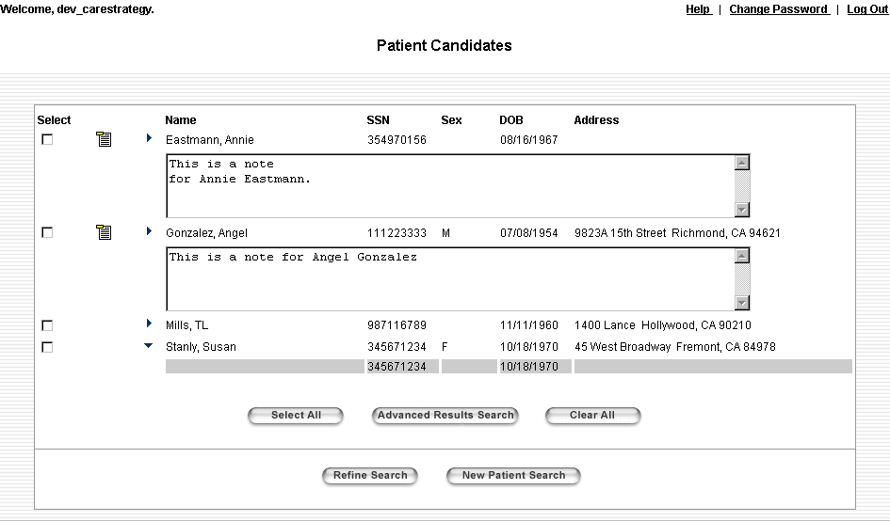

User Actions
- Right Arrow/Down arrow: Expands/collapses the aliases for a patient.
- Plus/Minus Document: Views/hides the read-only Note for the patient.
- Advanced Results Search: If a Patient is selected from the list, displays the Locate Results screen with those patients selected. If even one of the patients has not yet been selected in this session, the Consent Dialog box will first display (above). Users may only select up to 5 patients.
- Refine Search: Returns the user to the Find Patient screen; all of the user-entered information is retained and displayed.
- New Patient Search: Returns the user to the Find Patient screen; all of the user-entered information is discarded.
- Select All: Selects all patients in the list and enables all Add to List checkboxes, defaulting them to true.
- Clear All: Clears all selections from the patient list and disables all Add to List checkboxes.

Files
- PatientResultsMultiHtm.jsp: Displays the visual components

Clinician Admin User Differences
If the user also has Admin privileges, he will see one extra button on the Single Patient and Multiple Patient screens. Selecting this button allows the user to view the unique Patient ID for that patient. This Patient ID can be entered into LDAP when the user is creating a new Consumer user. Associating the unique Patient ID with a Consumer user allows the system to retrieve the Person when the Consumer logs in, since a Consumer can only view results for himself. Selecting this button on the Multiple Patient screen with more than one candidate selected will cause an error message. The ID is displayed in the form of a JavaScript prompt so that it can easily be copied and pasted into an LDAP window. This functionality is only temporary.

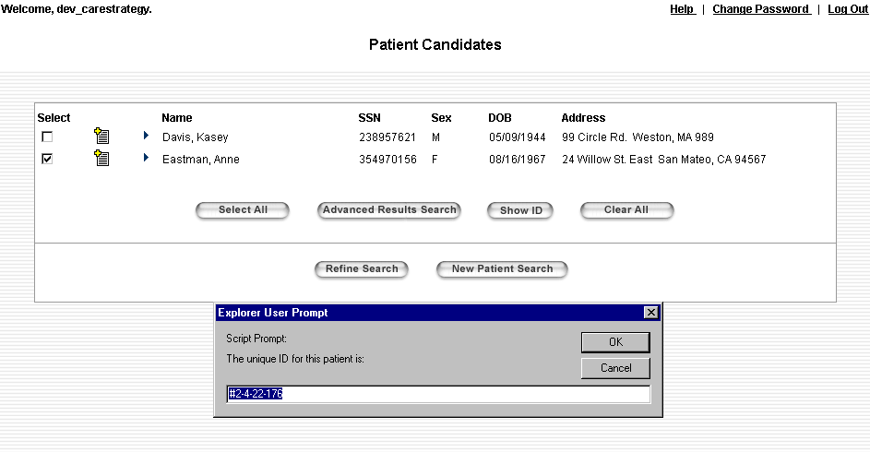

User Actions
- Show ID: Displays the Unique Patient ID for the selected patient. This is completely handled via JavaScript functions and does not cause a post to the server.

Common Files
- LocatePatient.jsp: Makes calls to the appropriate helper classes to search for the patients based on user selections from the Patient List or from user-entered ID or demographics. Stores the found patients in the session object and directs the flow to the proper next page.
- browser_info.jsp: Determines the browser type and version that the user is using and stores the results in the session object.
- no_cache.jsp: Sets the page so that it will be reloaded each time it is requested (and not just served from local cache).
- ValidSessionChkTop.jsp: Logic included at the top of each visible page that checks to see if the user session has timed out and if so, forwards to the Login page.
- ValidSessionChkBottom.jsp: Logic included at the bottom of each visible page that completes the block started in ValidSessionChkTop.jsp. Also has a CATCH block that forwards to the error page if and exception is thrown while processing the page.
- com.carescience.cde.ui.PatientResultsBean: JavaBean to support the JSPs in this module. Provides getter and setter methods for all screen-level controls on the screen. Also handles packaging selections to be used by subsequent screens.
- PatientResults.js: Contains routines to handle the button actions, screen controls, etc.
- com.carescience.cde.ui.PatientSearchMainBean: Provides getter and setter method for all screen-level fields on the Patient Search screen as well as some supporting methods. Used to determine what the user entered on the Patient Search screen to do the look up.
- com.carescience.cde.ui.PatientListWebImpl: Contains all the logic to access the back-end LDAP services that maintain the Patient Lists. Used to locate the patient when the user makes selections from the Patient List. Returns a List of Person objects
- com.carescience.cde.ui.LocatePatientBean: Uses the input entered by the user to access the ICS search for patient matches. Returns a List of Person objects.
- com.carescience.utility.JndiHelper: Gets the IdentityService
- com.carescience.cde.pids.IdentityService: Used to retrieve the Person
- com.carescience.cde.ui.WebKeys: List of constants used to access objects in the session object.
- com.protomatter.syslog.Syslog: Sends messages to the console
- PatientResults.jsp: This is really the main JSP for the Candidate List page. After it performs the logic common to all scenarios it includes the appropriate JSP (of the 4 stated above) based on the results of LocatePatient.jsp (ie, were there results?, does the user have access?, was there just one patient or more than one?).
- WelcomeHelpLogout.jsp: Displays the Welcome Bar (above).
- cde.css: This is the Cascading Style Sheet used by all the visible pages in the application.

My Profile (Consumer Only)
Purpose
The purpose of the My Profile screen is actually quite different from the Patient Candidates screen. This is the first screen that the Consumer sees after login. The Person is found at that time. We can retrieve the Person immediately, since an association was made between the user and the Person when the Consumer user was created – once the user logs in, we know which Person to display on this screen. The user can view his demography details here, including all aliases, in the same manner as the Patient Candidates screen. However, there is no selection process, since the Consumer can only view results for himself. There is also no Patient List tie-in. The user can view and modify his Notes.

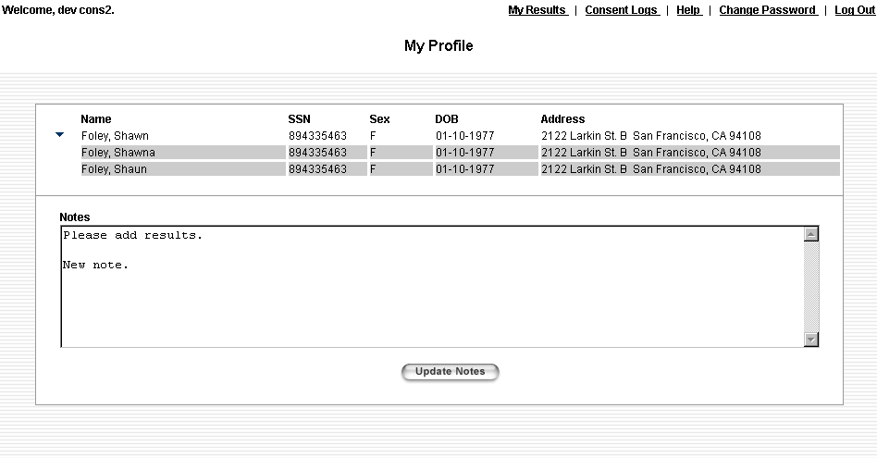
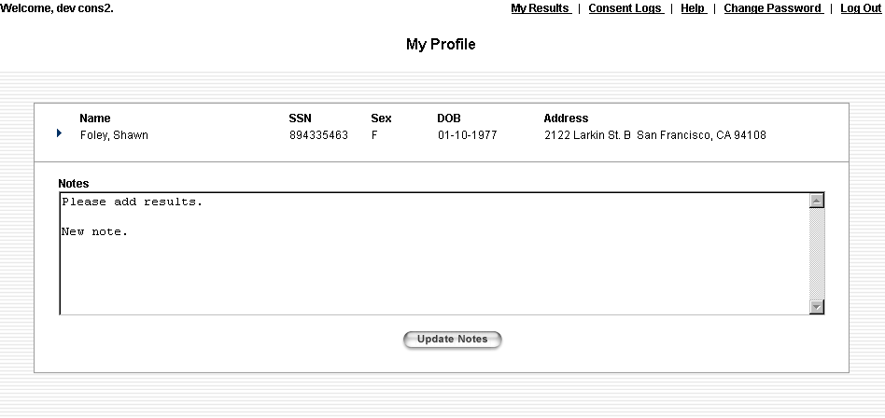
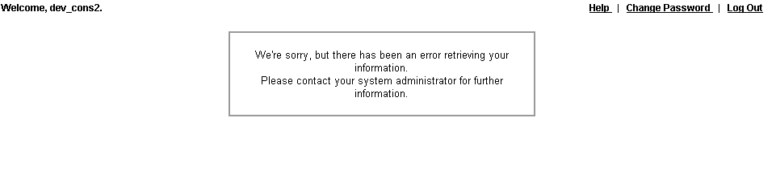
If there is some problem with retrieving the Person object for the Consumer user, the user cannot continue using the application. The user will see the following screen. Note that the user has no choices except to Log Out.

User Actions
- Right Arrow/Down arrow: Expands/collapses the aliases for a patient.
- Update Notes: Saves the Notes field
- My Results link: Takes the user to the Locate My Results page, where he can enter search parameters and then view results
- Consent Logs link: Takes the user to the Consent Logs page, where he can view users who have stated consent to view his information.

Files
- browser_info.jsp: Determines the browser type and version that the user is using and stores the results in the session object.
- no_cache.jsp: Sets the page so that it will be reloaded each time it is requested (and not just served from local cache).
- ValidSessionChkTop.jsp: Logic included at the top of each visible page that checks to see if the user session has timed out and if so, forwards to the Login page.
- ValidSessionChkBottom.jsp: Logic included at the bottom of each visible page that completes the block started in ValidSessionChkTop.jsp. Also has a CATCH block that forwards to the error page if and exception is thrown while processing the page.
- com.carescience.cde.ui.PatientResultsBean: JavaBean to support the JSPs in this module. Provides getter and setter methods for all screen-level controls on the screen. Also handles updating a Note.
- com.carescience.utility.JndiHelper: Gets thePersonIdService
- com.carescience.cde.pids.PersonIdService: Used actually update the Notes for a Person.
- PatientResults.js: Contains routines to handle the button actions, screen controls, etc.
- com.protomatter.syslog.Syslog: Sends messages to the console
- PatientResults.jsp: This is really the main JSP for the Candidate List page. After it performs the logic common to all scenarios it includes the appropriate JSP, which in this case is PatientResultsSingleHtm.jsp.
- PatientResultsSingleHtm.jsp: Displays the visual components
- com.carescience.cde.ui.WebKeys: List of constants used to access objects in the session object.
- WelcomeHelpLogout.jsp: Displays the Welcome Bar (above).
- cde.css: This is the Cascading Style Sheet used by all the visible pages in the application.
- LocatePatientConsumerError.jsp: Error message that is presented to the user if either his unique person ID cannot be retrieved from LDAP, or that ID cannot be used to retrieve the Person object.

Locate Results (Clinician Only)

Purpose
The Locate Results screen allows the user to specify which results he is interested in retrieving for the selected patients. There are 5 tabs, each of which corresponds to a data class and allows the user to select the specific data types of interest. Note that the data types are not hard-coded – they are read from an XML file. Above the tabs is a section that is available from every tab, which allows the user to select a date range or period and make a location selection. The selected patients are listed at the top of the screen as well.
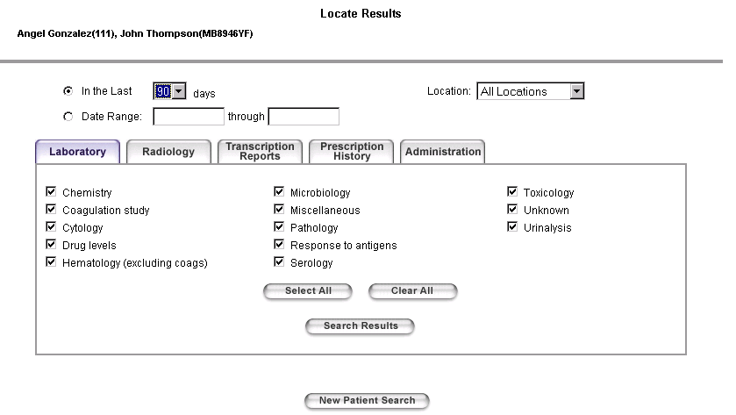
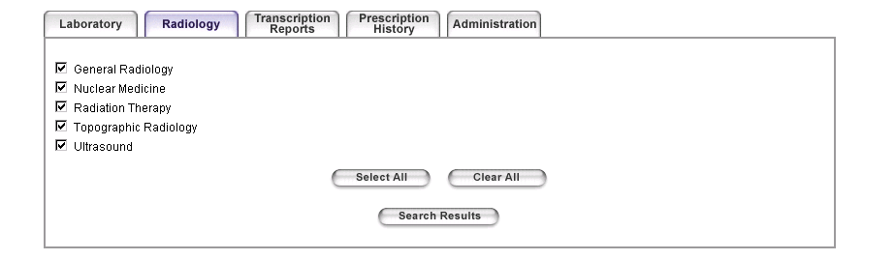
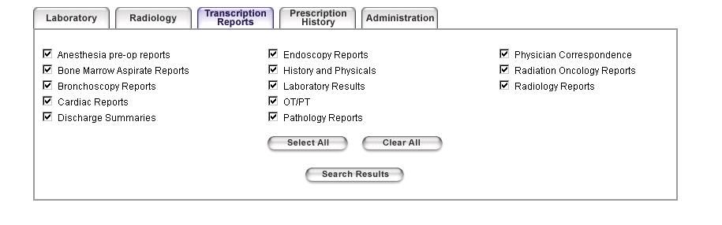

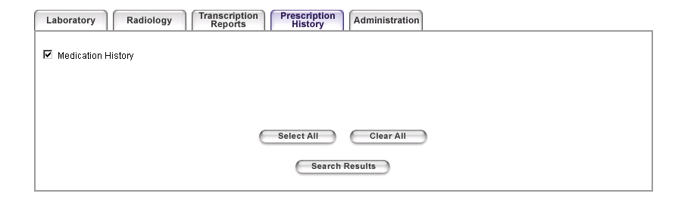
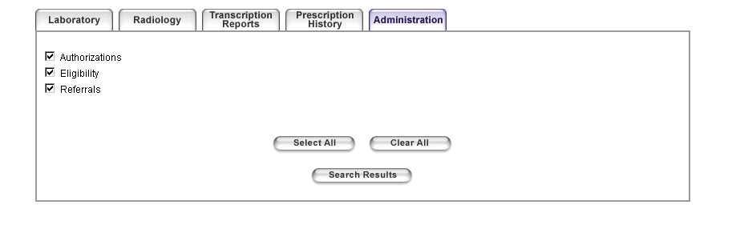
User Actions
- Tabs: Changes the currently displayed tab.
- Select All: Selects all data types on the current tab only.
- Clear All: Deselects all data types on the current tab only.
- Search Results: Launches a search for the selected data types for the selected patients within the selected date and location parameters.
- New Patient Search: Returns the user to the Find Patient screen; all of the user-entered information is discarded.

Files
- ResultTypesActionPage.jsp: Non-viewable page that acts as a gateway to the Locate Results screen – all pages post here for this module. Simply processes the request (via a RequestHandler) and directs the flow to the page returned from the RequestHandler.
- com.carescience.cde.ui.ResultsTypesRequestHandler: Inspects the action sent from the requesting page responds accordingly. Responsible for saving the request parameters to the JavaBean and also for providing the URL string for the next page.
- com.carescience.cde.ui.ResultTypesWebImpl: No functionality – extends ResultTypesMainAccessor
- com.carescience.cde.ui.ResultTypesMainAccessor: JavaBean to support the JSPs in this module. Initializes the values of the checkboxes and provides getter and setter methods for all screen-level controls on the screen. Also provides some utility methods for displaying the patient names and for packaging all of the selections to be sent to the ILS.
- com.carescience.cde.ils.ClinDataType: Used to initialize the values of the dynamic checkboxes on each tab from an xml file.
- com.carescience.cde.ils.ClinDataClass: Used to initialize the values of the dynamic checkboxes on each tab from an xml file.
- com.carescience.cde.ui.DataRequest: Contains the data request for a single patient. Associates a patient name with a ClinDataRequest object.
- com.carescience.cde.ils.ClinDataRequest: Contains the data request for a single patient. Contains all the user selections from the Locate Data page along with a patient identifier
- ResultTypeFrames.jsp: FrameSet that sets up the 3-frame structure of this module
- ValidSessionChkTop.jsp: Logic included at the top of each visible page that checks to see if the user session has timed out and if so, forwards to the Login page.
- ValidSessionChkBottom.jsp: Logic included at the bottom of each visible page that completes the block started in ValidSessionChkTop.jsp. Also has a CATCH block that forwards to the error page if and exception is thrown while processing the page.
- browser_info.jsp: Determines the browser type and version that the user is using and stores the results in the session object.
- SessionTimeoutWarning.jsp: Non-viewable Java and JavaScript code that warns the user that his session is about to expire. (above)
- com.protomatter.syslog.Syslog: Sends messages to the console
- com.carescience.cde.ui.WebKeys: List of constants used to access objects in the session object.
- ResultTypesTop.jsp: Displays the patient names(s) as well as the date and location controls. This JSP is available with all tabs.
- WelcomeHelpLogout.jsp: Displays the Welcome Bar (above).
- cdeUtil.js: Date validation routines
- ResultTypesTop.js: Contains routines to handle date controls – enabling and disabling, etc.
- ResultTypesBottom.jsp: Displays the New Patient Search button. This JSP is available with all tabs.
- ResultTypesLab.jsp: Displays the tabs and datatype checkboxes for the Laboratory tab.
- ResultTypes.js: Contains the JavaScript for the tabs, including switching between tabs, selecting and clearing all data types, etc.
- ResultTypesRadiology.jsp: Displays the tabs and datatype checkboxes for the Radiology tab.
- ResultTypesTranscription.jsp: Displays the tabs and datatype checkboxes for the Transcription Reports tab.
- ResultTypesPresHistory.jsp: Displays the tabs and datatype checkboxes for the Prescription History tab.
- ResultTypesAdmin.jsp: Displays the tabs and datatype checkboxes for the Administration tab.
- cde.css: This is the Cascading Style Sheet used by all the visible pages in the application.

Locate My Results (Consumer Only)
Purpose
The Locate My Results screen is similar to the Locate Results screen, but is more restrictive. It allows the user to specify which results he is interested in retrieving for himself. There are 5 checkboxes, each of which corresponds to a data type. Note that the data types are not hard-coded – they are read from an XML file. Selecting a data type will include in the search all the data classes that comprise that data type. (In contrast, the Clinician user can specify at the data class level which results should be searched for.) The user may also select a date range or period and make a location selection.

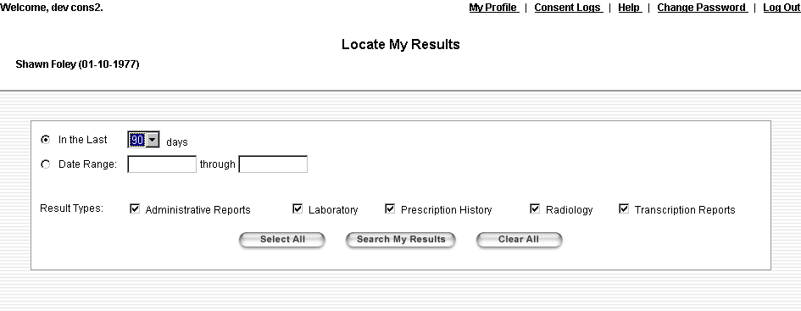

User Actions
- Select All: Selects all data types
- Clear All: Deselects all data types
- Search My Results: Launches a search for all the data classes for the selected data types for the user within the selected date and location parameters.
- My Profile link: Returns the user to the My Profile page, where he can view his aliases and update his notes
- Consent Logs link: Takes the user to the Consent Logs page, where he can view users who have stated consent to view his information.

Files
- ResultTypesActionPage.jsp: Non-viewable page that acts as a gateway to the Locate Results screen – all pages post here for this module. Simply processes the request (via a RequestHandler) and directs the flow to the page returned from the RequestHandler.
- com.carescience.cde.ui.ResultsTypesRequestHandler: Inspects the action sent from the requesting page responds accordingly. Responsible for saving the request parameters to the JavaBean and also for providing the URL string for the next page.
- com.carescience.cde.ui.ResultTypesWebImpl: No functionality – extends ResultTypesMainAccessor
- com.carescience.cde.ui.ResultTypesMainAccessor: JavaBean to support the JSPs in this module. Initializes the values of the checkboxes and provides getter and setter methods for all screen-level controls on the screen. Also provides some utility methods for displaying the patient names and for packaging all of the selections to be sent to the ILS.
- com.carescience.cde.ils.ClinDataType: Used to initialize the values of the dynamic checkboxes from an xml file.
- com.carescience.cde.ils.ClinDataClass: Used to specify the member Data Classes for each selected Data Type when packaging the request
- com.carescience.cde.ui.DataRequest: Contains the data request for a single patient. Associates a patient name with a ClinDataRequest object.
- com.carescience.cde.ils.ClinDataRequest: Contains the data request for a single patient. Contains all the user selections from the Locate My Data page along with a patient identifier
- ResultTypeConsumer.jsp: Contains all the visual elements for this page
- ValidSessionChkTop.jsp: Logic included at the top of each visible page that checks to see if the user session has timed out and if so, forwards to the Login page.
- ValidSessionChkBottom.jsp: Logic included at the bottom of each visible page that completes the block started in ValidSessionChkTop.jsp. Also has a CATCH block that forwards to the error page if and exception is thrown while processing the page.
- browser_info.jsp: Determines the browser type and version that the user is using and stores the results in the session object.
- SessionTimeoutWarning.jsp: Non-viewable Java and JavaScript code that warns the user that his session is about to expire. (above)
- com.protomatter.syslog.Syslog: Sends messages to the console
- com.carescience.cde.ui.WebKeys: List of constants used to access objects in the session object.
- ResultTypesTop.js: Contains routines to handle date controls – enabling and disabling, etc.
- ResultTypesConsumer.js: Contains the JavaScript for selecting and clearing all data types, etc.
- cdeUtil.js: Date validation routines
- WelcomeHelpLogout.jsp: Displays the Welcome Bar (above).
- cde.css: This is the Cascading Style Sheet used by all the visible pages in the application.

Patient Results/My Results (Consumer and Clinician)
Purpose
Once the user makes his selections and requests a results search, this page displays. The user will be able to see the progress of the search – the top frame of this page updates automatically, displaying the current status of the requests. When all requests are completed, the frame stops updating.

When the first request is complete, the results returned from the ILS will display in the bottom frame. A checked checkbox will appear next to the status for that request, but it will be disabled. This behavior only occurs for the first returned result.

When another request returns results, it too will get a checkbox next to its status, but it will be unchecked and enabled. The original result’s checkbox will also be enabled at that point. Now the user may select which patients’ results to view simultaneously by selecting enabled checkboxes and hitting the Show Results button. Note that if only one patient was selected or had results there is no need for the Show Results button and it does not display. Also, any request that does not return results will not have a checkbox.

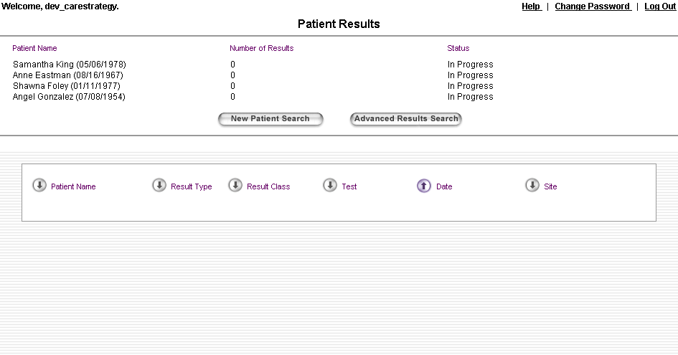
The user may also sort the results by any displayed column. The actual results themselves are viewed by clicking the hyperlink for the result of interest (to display one result) or selecting the checkbox next to the result and hitting the View Results button (to display multiple results).

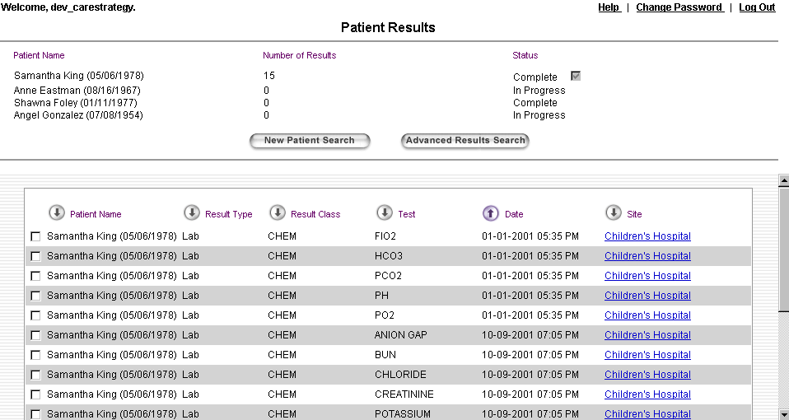

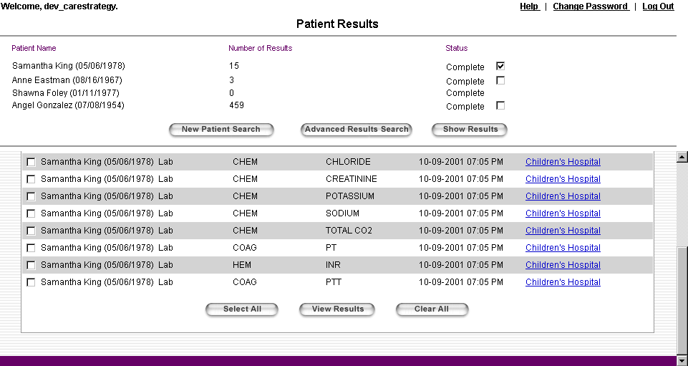

User Actions
- New Patient Search: Returns the user to the Find Patient screen; all of the user-entered information is discarded.
- Advanced Results Search: Returns the user to the previous page where he can make different results selections for the same selected patients and search again.
- Show Results: If there is only one patient that has results this button does not appear. Otherwise, the user may select any combination of patients and hit refresh to display the results for just these patients. Any patient that does not have results will appear at the top of the screen as usual, but will have a disabled checkbox just as if only one patient were selected.
- Down Arrow: Causes the results to be sorted by the column corresponding to the down arrow, in ascending order.
- Up Arrow: Causes the results to be sorted by the column corresponding to the up arrow, in descending order.
- Hyperlinks in Site column: Causes a pop-up box to be displayed that contains the specified results for that patient.
- Select All: Selects all results in the list
- View Selected Results: Launches the View Results screen allowing the user to view each of the selected results.
- Clear All: Deselects all results in the list

Consumer User Differences
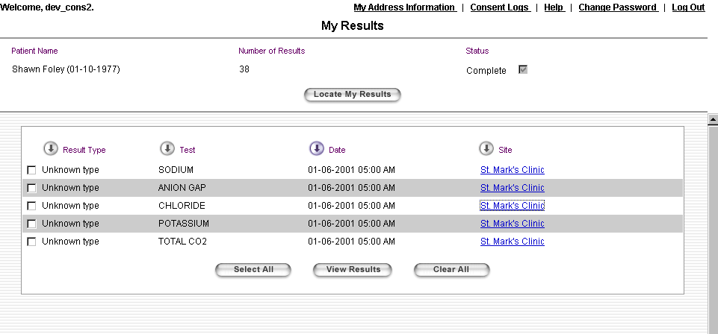
This screen does not change significantly for the Consumer. There is a title and button change, as well as 2 navigation links. There will only ever be one patient on this screen, since the Consumer can only access himself. Also, Consumer users do not see the Patient Name or Result Class columns.

- My Demography link: Returns the user to the My Demography page, where he can view his aliases and update his notes
- Consent Logs link: Takes the user to the Consent Logs page, where he can view users who have stated consent to view his information.
- Locate My Results button: Returns the user to the previous page where he can make different results selections and search again.

Files
- PatientDataResultsActionPage.jsp: Non-viewable page that acts as a gateway to the Results Progress and Data screen – all pages post here for this module. Simply processes the request (via a RequestHandler) and directs the flow to the page returned from the RequestHandler.
- com.carescience.cde.ui.PatientResultsRequestHandler: Inspects the action sent from the requesting page responds accordingly. Responsible for providing the URL string for the next page
- com.carescience.cde.ui.PatientResultsMainAccessor: Contains getter and setter methods for all the visual controls of the Results Progress and Data screen. Also contains other methods to support this module like packaging and sending a request to the ILS, merging lists of results and sorting results.
- com.carescience.utility.CSProperties: Utility file that provides access to the CDE.properties file. This file contains the text for the various results statuses.
- com.carescience.cde.ui.DataRequest: Contains the data request for a single patient. Associates a patient name with a ClinDataRequest object.
- com.carescience.cde.ils.ClinDataRequest: Contains the data request for a single patient. Contains all the user selections from the Locate Data page along with one or more patient identifiers.
- com.carescience.cde.ui.DataResult: Contains all the result information associated with a request including the results list, the patient name and various status information. The DataResult and ClinDataRequest objects are linked together with a unique person ID.
- com.carescience.cde.ils.adapter.CdeLocatorAdaper_WL: Interface to the ILS
- com.protomatter.syslog.Syslog: Sends messages to the console
- ResultsPDFrames.jsp: Frameset that includes ResultsProgress.jsp and PatientDataResultsFrames.jsp. This file ties together the progress and data portions of the screen.
- ValidSessionChkTop.jsp: Logic included at the top of each visible page that checks to see if the user session has timed out and if so, forwards to the Login page.
- ValidSessionChkBottom.jsp: Logic included at the bottom of each visible page that completes the block started in ValidSessionChkTop.jsp. Also has a CATCH block that forwards to the error page if and exception is thrown while processing the page.
- browser_info.jsp: Determines the browser type and version that the user is using and stores the results in the session object.
- no_cache.jsp: Sets the page so that it will be reloaded each time it is requested (and not just served from local cache).
- SessionTimeoutWarning.jsp: Non-viewable Java and JavaScript code that warns the user that his session is about to expire. (above)
- ResultsProgress.jsp: Displays the status of each request. This frame is on a timer that periodically refreshes with the most current information. This page also allows the user to select one or more completed requests to view the results.
- ResultsProgress.js: Contains the JavaScript for this page to handle view results for different patients, etc.
- WelcomeHelpLogout.jsp: Displays the Welcome Bar (above).
- com.carescience.cde.ui.WebKeys: List of constants used to access objects in the session object.
- PatientDataResultsFrames.jsp: Frameset for the results frame. There is only 1 visible frame in this frameset. The second frame only exists so that we can post to it to accommodate the View Results screen (below). This page handles closing the View Results page whenever the Result page refreshes. See below for more information.
- PatientDataResults.jsp: Displays the results and allows the user to select one or more to view (this is the visible frame in the PatientDataResultsFrames frameset).
- PatientDataResults.js: Contains the JavaScript for this page to handle sorting, etc.
- PatientDataResultsDummy.html: This is the placeholder in the PatientDataResultsFrames frameset definition for the non-viewable frame that is used to accommodate the View Results screen.
- ViewResultsPost.jsp: Uses JavaScript to launch the View Results pop-up window (below).
- cde.css: This is the Cascading Style Sheet used by all the visible pages in the application.

View Results (Consumer and Clinician)
Purpose
This pop-up screen allows the user to quickly browse through multiple patient results without the use of hyperlinks. All the results that were selected from the Patient Results screen will be maintained by this page. If the user selected more than one results, he can navigate through them sequentially and can also jump to the beginning and end of the list of URLs. Note that if the user only selected one result, no buttons display.

This page will automatically be closed any time the results page (above) is refreshed. In other words, if the user merges or sorts results, this page will close. This is necessary because this page shares the same list of results as the results page and is indexed accordingly. If the results page changes, this page becomes invalidated. This page will also close when the user leaves this page, either voluntarily or because of a timeout.

The only other time the results page refreshes is after the user responds to a timeout warning. Whether the user answers Yes or No to the timeout warning, this page will still close. Once the user gets a timeout warning from the results page (note that this page does not have it’s own timeout warning), the user can still interact with this page. However, if the user does not address the timeout warning and the session becomes invalidated, this page will automatically close the next time the user causes it to post.

The closing mechanism is accomplished using an IE JavaScript feature called Persistence Behaviors. This functionality is built into IE 5.5 and allows you to store JS variables between page invocations. Here is a blurb taken from http://www.blox.tv/ie_55_editor:
"The UserData behavior is a great way to persist content from contentEditable elements to a store on the user's machine. Behaviors were introduced in Internet Explorer 5.0 as a way to encapsulate reusable script and/or HTML. A behavior lives in its own file, called an HTC (HTML Component) file, which is referenced from a CSS style block in the head of the client document. You apply a behavior to an element the same way you apply a CSS style. Once a behavior is associated with an element, all the methods belonging to the behavior can be invoked on that element."

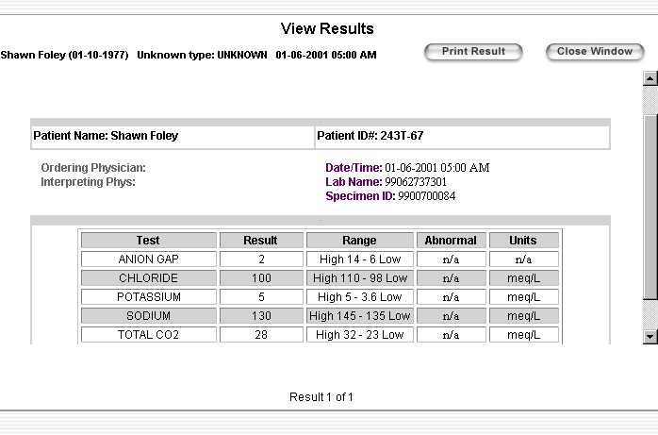

User Actions
First: Displays the first result selected by the user on the Patient Results page
Previous: Displays the previous result selected by the user on the Patient Results page
Next: Displays the next result selected by the user on the Patient Results page
Last: Displays the last result selected by the user on the Patient Results page

Clinician User Differences
Clinician may also authorize the Consumer to be able to view this result by checking the Authorize checkbox. Unchecking the box will remove authorization. Consumers may only view results that have been authorized in this manner. Note that only the Clinician sees this checkbox.
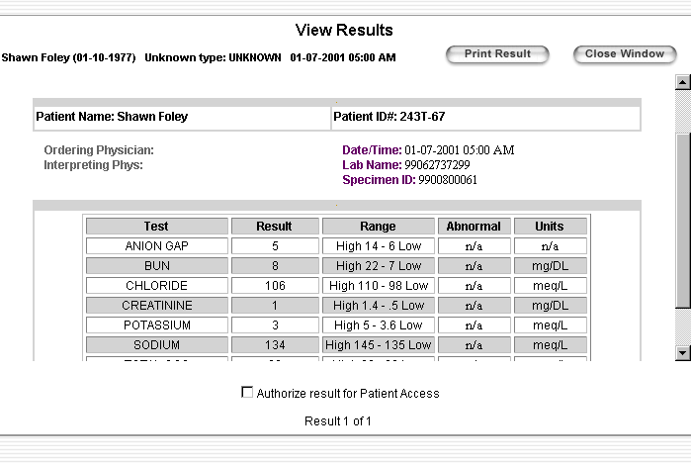
- Select/unselect Authorize checkbox: authorizes or removes authorization for this result. The page will refresh and the current value of the checkbox should redisplay.

Files
- ViewResultsFrm.jsp: Frameset for this page. Button selections (First, Previous, etc) post to this page. This page also checks to make sure the session is still valid and closes the pop-up if it is not.
- ViewResultsTop.jsp: Displays the header and title and sets up the username strings.
- ViewResultsBottom.jsp: Displays the buttons and result index.
- ViewResultsBottom.js: Contains the JavaScript to respond to the navigation buttons, etc.
- ViewResultsMain.jsp: Placeholder JSP that just does a jsp:forward to the ResultServlet
- com.protomatter.syslog.Syslog: Sends messages to the console
- no_cache.jsp: Sets the page so that it will be reloaded each time it is requested (and not just served from local cache).
- com.carescience.cde.ui.WebKeys: List of constants used to access objects in the session object.
- com.carescience.cde.ui.PatientResultsMainAccessor: Maintains the list of selected results and the index of the currently viewed result. Contains the getter and setter methods needed to support the header information, total results, etc. Also used by ResultServlet to get the URL of the currently viewed result.
- com.carescience.http.ResultServlet: Access the URL of the current result from the JavaBean and mediates the HTML between the client system and the UI. Also logs the results viewed.
- cde.css: This is the Cascading Style Sheet used by all the visible pages in the application.
- com.carescience.cde.ui.UiLogger: Logs viewed results to a database.
- com.carescience.cde.ils.adapters.LocatorResFilter: Maintains the Authorization flag for results

Consent Logs (Consumer Only)
Purpose
This screen allows the user to view information about instances when Clinician users have stated that they have consent to view the Consumer user’s results. Clinician users assert this consent using the Consent Dialog (above). Each time the Clinician does this it is logged and this screen allows the consumer to view those logs. The screen defaults to showing all instances across all locations over the past 90 days. The user may change these parameters and rerun the report. He may also sort the log report.

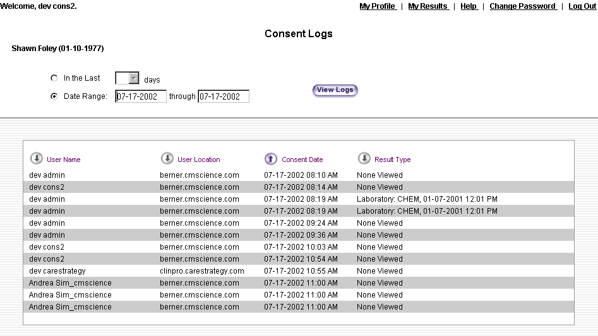
User Actions
- Down Arrow: Causes the log entries to be sorted by the column corresponding to the down arrow, in ascending order.
- Up Arrow: Causes the log entries to be sorted by the column corresponding to the up arrow, in ascending order.
- View Logs: Refreshes the report based on the user-entered parameters

Files
- com.carescience.cde.ui.ConsentLogMainAccessor: JavaBean to support the JSPs in this module. Provides getter and setter methods for all screen-level controls on the screen. Also provides some utility methods for displaying the patient names and for updating request parameters
- ConsentLog.jsp: Contains all the visual elements for this page
- ValidSessionChkTop.jsp: Logic included at the top of each visible page that checks to see if the user session has timed out and if so, forwards to the Login page.
- ValidSessionChkBottom.jsp: Logic included at the bottom of each visible page that completes the block started in ValidSessionChkTop.jsp. Also has a CATCH block that forwards to the error page if and exception is thrown while processing the page.
- browser_info.jsp: Determines the browser type and version that the user is using and stores the results in the session object.
- SessionTimeoutWarning.jsp: Non-viewable Java and JavaScript code that warns the user that his session is about to expire. (above)
- com.protomatter.syslog.Syslog: Sends messages to the console
- com.carescience.cde.ui.WebKeys: List of constants used to access objects in the session object.
- ResultTypesTop.js: Contains routines to handle date controls – enabling and disabling, etc. In order to be able to reuse the JavaScript routines, which originated in the Results Type screen, we need to call the frame in this module ResultTypes.
- ConsentLog.js: Contains the JavaScript for viewing the logs, etc.
- cdeUtil.js: Date validation routines
- WelcomeHelpLogout.jsp: Displays the Welcome Bar (above).
- cde.css: This is the Cascading Style Sheet used by all the visible pages in the application.

Administration (Clinician Only)
Purpose
This screen allows the Clinician to add, delete and rename patient lists as well as remove patients from patient lists. This screen also allows the Clinician to associate a polling frequency with patient lists.

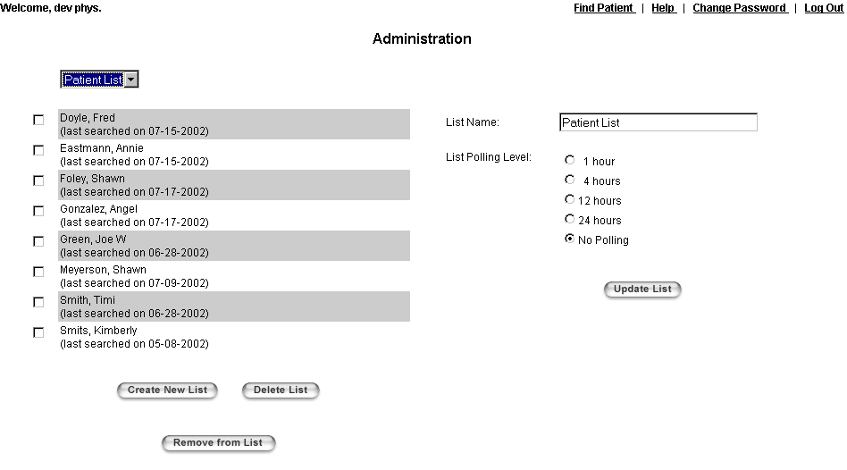

User Actions
- Create New List: Prompts the user for a new list name and creates a new patient list of that name. The screen will refresh to display the defaulted information for the new list. The user may not create more than 10 lists.
- Delete List: Deletes the current list, redisplaying the screen with the first patient list in alphabetic order. The user may not remove his last patient list.
- Remove From List: Removes the selected patients from the Patient List.
- Change Patient List DDLB: Displays the patients in the selected patient list along with the appropriate Polling Level.
- Update List: Updates the List Name and List Polling Level for the current list.

Files
- Admin.jsp: Gets the Patient List values and displays all the patients in that list as well as the current Polling Level. Allows the user to update all of this information.
- browser_info.jsp: Determines the browser type and version that the user is using and stores the results in the session object.
- no_cache.jsp: Sets the page so that it will be reloaded each time it is requested (and not just served from local cache).
- SessionTimeoutWarning.jsp: Non-viewable Java and JavaScript code that warns the user that his session is about to expire. (below)
- WelcomeHelpLogout.jsp: Displays the Welcome Bar (above).
- ValidSessionChkTop.jsp: Logic included at the top of each visible page that checks to see if the user session has timed out and if so, forwards to the Login page.
- ValidSessionChkBottom.jsp: Logic included at the bottom of each visible page that completes the block started in ValidSessionChkTop.jsp. Also has a CATCH block that forwards to the error page if and exception is thrown while processing the page.
- admin.js: Contains the JavaScript for this page, including the button action methods
- incBrowserType.js: Determines the browser type and version that the user is using
- incResize.js: Refreshes the page to handle the Netscape resizing problem.
- com.carescience.cde.ui.WebKeys: Contains the keys to retrieve the JavaBeans from the session.
- com.protomatter.syslog.Syslog: Sends messages to the console
- com.carescience.cde.ui.PatientListWebImpl: Contains all the methods for maintaining patient lists (creating, deleting, renaming, etc.) as well as the methods to read and update the polling level.
- com.carescience.cde.ui.AdminMainBean: Provides getter and setter method for all screen-level fields.
- cde.css: This is the Cascading Style Sheet used by all the visible pages in the application.

Major Dependencies
Certificates
The user must have a valid certificate to use CDE. Login.jsp uses helper classes to inspect the certificate and extract information from it. This information is then used, for example, to authenticate the user’s login and password, to identify the user in the logs, and to access the user’s Patient Lists.

Logging
There are 2 types of logging in CDE. com.protomatter.syslog.Syslog is used frequently and merely sends messages in a formatted way to the console. It is primarily a debugging tool. com.carescience.cde.ui.UiLogger actually makes an entry to a persistent storage log. This is used in login.jsp to record that the user logged in and also if the user’s session timed out. It is used again in ConsentDialog.jsp to record whether the user responded Yes or No from the Consent Dialog.

LDAP
Information about CDE users is stored in an LDAP server. This server supports the login process including the User Roles and Person ID user for the Consumer module. It is also where the users Patient Lists are stored along with the polling data. When the user hits the Change Password link from WelcomeHelpLogout.jsp, he is directly accessing the LDAP server. The resulting windows are completely outside of the CDE product. Is this still true?

Patient List/Polling
As was just mentioned, all Patient List information is stored in the LDAP server. com.carescience.cde.ui.PatientListWebImpl.java accesses a mediator class that provides all the necessary services to read from and write to this server.

Notes
Althought Consumer Notes are returned through the Person object returned from the ICS without any special interface, updating a note requires the com.carescience.cde.pids.PersonIdService service. This is done in com.carescience.cde.ui.PatientResultsBean.

ICS
When the user enters demographic data or an ID and chooses to search for patients, com.carescience.cde.ui.LocatePatientBean handles packaging the user input and submitting a request for a patient search. The request is submitted to a com.carescience.cde.pids.IdentityService that was instantiated via JNDI. This service is responsible for returning a list of com.carescience.data.Person objects representing the correlated patients found in the search. This service is also used in login.jsp if the user is a Consumer. The Consumer’s PersonID is retrieved from LDAP and sent to the service to lookup his com.carescience.data.Person object.

Data Classes
When the user hits the Advanced Results Search button to get to the Locate Results page, there are 5 tabs. The tabs (data types) themselves are hard-coded, but the checkboxes within each tab (data classes) are dynamic. com.carescience.cde.ui.ResultTypesMainAccessor uses helper classes to determine what data classes should be displayed in each tab. The helper classes in turn are parsing the data from config/cts.xml.

ILS
Once the user has selected patients and chooses to do a Results Search, all of the user’s selections are packaged and sent to the ILS in com.carescience.cde.ui.PatientResultsMainAccessor. This class creates a com.carescience.cde.ils.adapters.CdeLocatorAdapter_WL object, which takes the request and results and asynchronously updates the results.

A blurb on Oracle/RDBMS would be good.

I don’t know if this is the right place to also mention the neural network or Intelligent Search programs?

Administration Console –

Header Frame
Purpose
The Header Frame is at the top of every page in the application. It provides access to functions that should always be available.

User Actions
- Privacy Policy: Displays the static CareScience privacy policy in a separate window. (see below)
- Contact Us: Displays the static CareScience contact information for the CDE product in a separate window. (see below)
- CareScience: Displays the CareScience homepage in the current window.

Files
- index.jsp: This is the main FrameSet for the entire application. The first frame is the header, the second frame is the navigation menus, and the third frame is where all the remaining pages reside.
- CareScienceHeader.html: This is the actual header file.
- incOpenWin.js: This file contains the JavaScript code that handle the creation of a separate window.
- cde.css: This is the Cascading Style Sheet used by all the visible pages in the application.

Privacy Policy
Purpose
This page displays CareScience’s privacy policy.

User Actions
None

Files
- cde_privacy_policy.html: static page
- cde.css: This is the Cascading Style Sheet used by all the visible pages in the application.

Contact Us
Purpose
This page displays CareScience contact information for the CDE application.
User Actions
None

Files
- cde_contact_info.html: static page
- cde.css: This is the Cascading Style Sheet used by all the visible pages in the application.

Login
Purpose
This page allows the user to login to the application. The user must have already selected a suitable certification for the session.
User Actions
- Login: Authenticates the User Name and Password. If the User Name/Password are correct, the user is logged in and taken to the Find Patient screen. Otherwise, an alert box with an error message is displayed.

Files
- login.jsp: Handles the display as well as the processing. Tries to authenticate the user and if succesful, writes an entry to the log and fills some session variables. Also logs when the user times out.
- handleSecurityError.html: Displays an error message when the login page determines that there is no certificate. I was not able to duplicate the conditions that cause this page to display.
- no_cache.jsp: Sets the page so that it will be reloaded each time it is requested (and not just served from local cache).
- browser_info.jsp: Determines the browser type and version that the user is using and stores the results in the session object.
- incBrowserType.js: Determines the browser type and version that the user is using to support the browser_update.jsp functionality.
- browser_update.jsp: Alerts the user if he is using an unsupported browser and offers links to acquire a supported browser version.
- error_handler.jsp: The default error page for the application – displays the error message in a more friendly format
- style_sheet.jsp: Contains style sheet entries – used by error_handler.jsp and browser_update.jsp, not login.jsp
- incResize.js: Refreshes the page to handle the Netscape resizing problem.
- com.carescience.http.Http: Encodes the username for proper HTML display
- com.protomatter.syslog.Syslog: Sends messages to the console
- com.carescience.cde.ui.UiLogger: Logs to the DB when a user times out and logs in
- com.carescience.security.ldap.LDAPUtil: Manipulates the certification
- com.carescience.security.ldap.LDAPAuthenticate: Handles the authentication of the User Name/Password
- cde.css: This is the Cascading Style Sheet used by all the visible pages in the application.

Index
Purpose
This page holds 3 frames. The CareScienceHeader.jsp at the top frame. The left navigation frame is folderTreeLeftFrame.jsp. The main frame is occupied by the HomePage.jsp upon initial login but this space is filled with the main content when user clicks on the link on the left.

User Actions
- No action occurs on this particular page – only within the frames that it holds.

Files
- SessionTimeoutWarning.jsp: Non-viewable page that created the JavaScript needed to support this feature. The viewable needs page still to setup the correct script for the onLoad event to enable this feature.

Session Timeout Warning
Purpose
For security reasons, the user session is set to expire after a certain period of inactivity. This feature warns the user at a preset period of time before the session is set to expire. The user is given the opportunity to repost the current page, which resets the session timeout clock.

User Actions
- OK: Reposts the current page, resetting the session timeout clock. The user will see the page flash as the page posts and any changes to values on that screen will be lost.
- Cancel: Logs the user out and takes him to the Login screen

Files
- SessionTimeoutWarning.jsp: Non-viewable page that created the JavaScript needed to support this feature. The viewable page still needs to setup the correct script for the onLoad event to enable this feature.
- incUtil.js: Various JavaScript utilities, including one to change the current page contents.
- ModalDialogLib.js: Supports the Consent Dialog box displaying as a modal dialog. Since

FolderTreeLeftFrame
Purpose
A html file that contains all the navigation for the Administration and Monitoring console.

User Actions
- Handles any links within the Administration console.
- Only the links in bold are active links that currently have the functionality.

Files
- Ftiens4.js: Creates the functionality of the folders and images.
- DefineMyTree.js: Defines all the links and where it leads to.

DisplayLogs
Purpose
To display ICS or local ILS log files to the user upon request.

User Actions
- User searches under a date range and the search results.

Files
- LogFiles.jsp: Form page that takes in the user input of ICS or ILS, the date range and the Log levels.

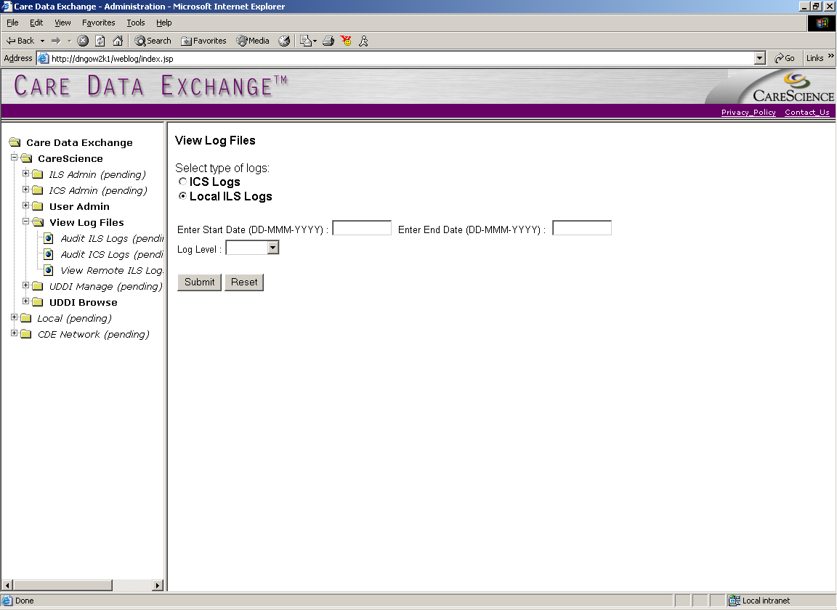
- DateFormatBean.jsp: Clarifies the date format in the JSP.

UDDIBrowse
Purpose
To browse business entities and their services for the administrator.

User Actions
- User clicks on the left navigation (UDDIBrowse) and upon page load, the query for the business entities will run. From there, the user is able to choose with business they would like to see the services from.

Files
- UDDIManage.java: Sets the query for business entity and services searches.
- DisplayBusinesses.jsp: Page that displays businesses returned from search.
- DisplayServices.jsp: Displays the service under the business marked from “Browse Businesses”.

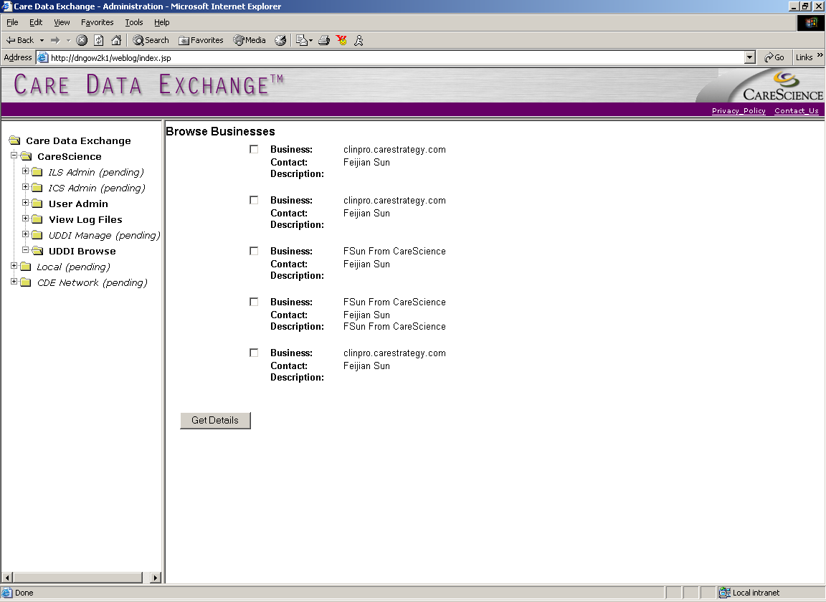

Major Dependencies
Certificates
The user must have a valid certificate to use CDE. Login.jsp uses helper classes to inspect the certificate and extract information from it. This information is then used, for example, to authenticate the user’s login and password, to identify the user in the logs, and to access the user’s Patient Lists.

Logging
There are 2 types of logging in CDE. com.protomatter.syslog.Syslog is used frequently and merely sends messages in a formatted way to the console. It is primarily a debugging tool. com.carescience.cde.ui.UiLogger actually makes an entry to a persistent storage log. This is used in login.jsp to record that the user logged in and also if the user’s session timed out. It is used again in ConsentDialog.jsp to record whether the user responded Yes or No from the Consent Dialog or just closed the dialog box.

LDAP
Information about CDE users is stored in an LDAP server. This server supports not only the login process, but it is also where the user’s Patient Lists are stored. When the user hits the Change Password link from WelcomeHelpLogout.jsp, he is directly accessing the LDAP server. The resulting windows are completely outside of the CDE product.

ICS –
ICS is currently built using either the JBuilder environment or using a build script. The build script will be different for Windows and UNIX machines and will have to be updated to reflect any changes in Package Structure in the future. If the build script is available, it will be either in the root or in the /bin directory of the CDE installation.

In the current setup, the classes that form the ICS and its dependencies are available as Java Class files, packaged into jar files deployable as an Install Anywhere Application.

Properties file setup –
The Identity Correlation Service (ICS) uses a configuration file to define it’s operation, performance, and administration. This file is located at <CDE_root>/config/CDE.properties. CDE.properties file contains various segments, each pertaining to a specific task as required by the ICS explained below:

* Location of Neural Network file
LOCA_NN_FILE = /opt/cde1.2/corsys.nn

* Location of the Intelligent Search 3rd party (JIST) libraries
JIST_WIN_DLL = c:\\projects\\Cde1.2\\jistdll.dll (for windows)
JIST_UNIX_SO = /opt/cde1.2/libist.so (for UNIX)

* Initial JNDI factory name for lookup purposes
JNDI_FACTORY = weblogic.jndi.WLInitialContextFactory

* LDAP Context factory for lookup purposes
LDAP_FACTORY = com.sun.jndi.ldap.LdapCtxFactory

* IIOP URL of the WebLogic Server to be connected to
IIOP_URL = t3://localhost:7001

* Correlation system output files for the batch load
TIME_FILE = /opt/cde1.2/data/time.txt
DUPLICATE_FILE = /opt/cde1.2/data/duplicates.txt
DUPLICATE_DETAIL_FILE = /opt/cde1.2/data/duplicates_detail.txt
SIMILAR_DETAIL_FILE = /opt/cde1.2/data/similar_detail.txt

* Error Reporting configuration properties. For reporting system errors
ERROR_FILE = error.txt
MAIL_SERVER = smtp.carescience.com
SENDER_ADDRESS = error_report@carescience.com

* PersonContainerMgr property. Name of the container in Objectivity
CONTAINER_MANAGER_NAME = PEOPLE

* JNDI bind names for the two ICS services. Used for lookup
* PersonIdService - JNDI bind name property
PID_JNDI_BIND_NAME = com.carescience.cde.pids.PersonIdService
* IdentityService - JNDI bind name property
ID_JNDI_BIND_NAME = com.carescience.cde.pids.IdentityService

* Syslog Configuration File Location
SYSLOG_CONFIG_FILE = /opt/cde1.2/Syslog.config.xml

* ICSLogServlet properties
LOG_DB_DRIVER = oracle.jdbc.driver.OracleDriver
LOG_DB_URL = jdbc:oracle:thin:cde_admin/cde_admin@test-oracle01.carescience.com:1521:LDEV

* For CSBatchLoader. Location of the text data file for batch load
LOCA_CSAMP_FILE = /opt/cde1.2/data/SansumdirectWithDNS.csv

* Location of the LDAP properties file for user authentication at GUI
LDAP_PROPERTIES_FILE = /opt/cde1.2/config/ldap.properties

* Path Info Defined in XMLPaths.jsp
STYLE_SHEET_PATH = /opt/weblogic/myserver/public_html/cde/XML/XSL/
XML_DOC_PATH = /opt/weblogic/myserver/public_html/cde/XML/XMLSource/
XML_DOC_PATH_PROCESS = /opt/weblogic/myserver/public_html/cde/XML/XMLSource/

There are other properties in a typical CDE.properties file, which are either required for test classes or are obsolete properties, left in there for version compatibility. These mainly include the HL7 codes and properties for the handlers and MPIServlet. These will be removed in subsequent releases.

Multiple Patient Search
The IdentityService interface for CDE 2.0 has a new method

List getProfileList(List identifiers) throws RemoteException, IdentityServiceException;

This method takes in a list of PersonIdentifier Objects and searches the database for their corresponding Person Objects.

In the implementation, viz., in IdentityServiceImpl Class, all it does is iterate through the list of input PersonIdentifier Objects and call the getProfile() method of the IdentityService for each. It then collects the returned Person Objects into a list and returns them as output.

NOTE: There is no particular ordering of the Person Objects returned from this method of the IdentityService service. Since the UI send an ArrayList of PersonIdentifiers and since the IdentityService iterates through these identifiers, they can be expected to be in the same order as that of the incoming requests.

PatientListMediator

ICS now has a new interface called PatientListMediator, which enables a user to temporarily persist a patient search history list in a Lightweight Directory Access Protocol (LDAP) server.

Users will be able to persist their search history list in their respective directories in LDAP. This is achieved by passing the user’s login credentials from their certificate by the UI to the PatientListMediator service.

TECH SERVICES NOTE: This service needs to started with the underlying (web/App) Server at Server startup. In this case WebLogic.

TECH SERVICES NOTE: The URL to the LDAP Server and the port on which it runs needs to be mentioned in the CDE.properties file.

LDAP Configuration for new Classes and Attributes (These were made as of CDE 2.0 and are shown here for documentation reasons only).

TECH SERVICES NOTE: This section is specifically for tech services.

A few new Attributes and Classes need to be created and configured in the LDAP Server that will serve this purpose. The Attributes are:
- name
- pListNames
- pl-listName
- pl-listEntries
- ple-createDate
- ple-displayName
- ple-domain
- ple-id
- ple-modifyDate

The Classes are:
- patientlistentry
- patlist
- patientlistmediator

The following pages display the screen shots of all the new Attributes and Classes.

name
The ‘name’ attribute will form the entity name attribute of each of the new LDAP Entity Classes. This is a ‘Case Exact String’ data type and is a single value attributes. The Object identifier is optional.

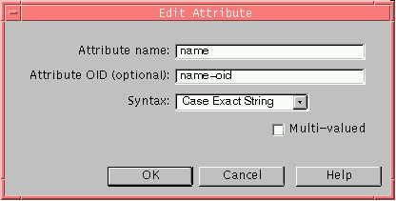

pListNames
The ‘pListNames’ attribute is the optional attribute in the ‘patientListMediator’ LDAP Entity. It is a ‘Case Exact String’ data type and denotes the list of PatientList Objects each user contains in his/her directory. Though this is a multi-value attribute, we currently use just one list per user. The Object identifier is optional.

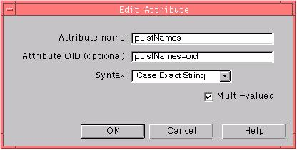

pl-listName
The ‘pl-listName’ attribute is the other required attribute after name of the ‘patList’ LDAP Entity. It is a ‘Case Exact String’ data type and denotes the name of the PatientList Object. It is a single-value attribute.

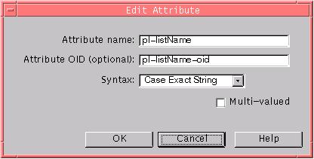

pl-listEntries
The ‘pl-listEntries’ attribute is the optional attribute of the ‘patList’ LDAP Entity. It is a ‘Case Exact String’ data type. It is a multi-value attribute. Each of these values denotes a PatientListEntry Object associated with the current PatientList Object.

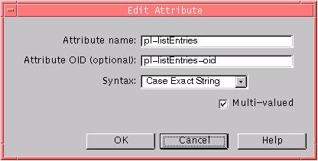

ple-createDate
The ‘ple-createDate’ attribute denotes the created time stamp attribute of the PatientListEntry Object. It is a ‘Case Exact String’ data type. It is a single-value attribute.

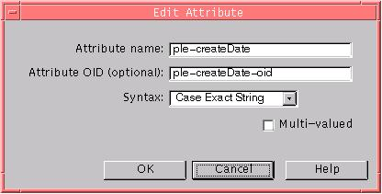

ple-displayName
The ‘ple-displayName’ attribute denotes the display name attribute of the PatientListEntry Object. It is a ‘Case Exact String’ data type. It is a single-value attribute.

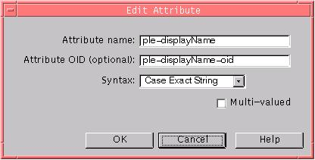

ple-domain
The ‘ple-domain’ attribute denotes the domain attribute of the PatientListEntry Object. It is a ‘Case Exact String’ data type. It is a single-value attribute.

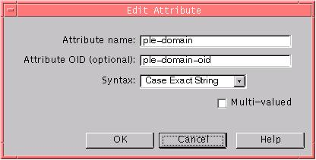

ple-id
The ‘ple-id’ attribute denotes the identifier (id) attribute of the PatientListEntry Object. It is a ‘Case Exact String’ data type. It is a single-value attribute.

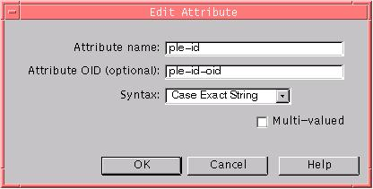

ple-modifyDate
The ‘ple-modifyDate’ attribute denotes the modified date attribute of the PatientListEntry Object. It is a ‘Case Exact String’ data type. It is a single-value attribute.

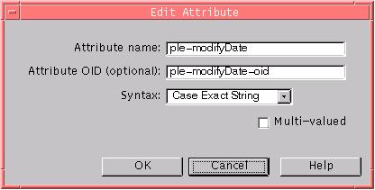

patientlistentry
Each ‘patientListEntry’ Class in LDAP denotes a PatientListEntry Object persisted in LDAP. It has a one-to-one mapping to the com.carescience.cde.plist.PatientListEntry Class.

It extends from LDAP’s base ‘top’ Class and has an optional Object identifier. It has six required attributes. They are name, ple-createDate, ple-displayName, ple-domain, ple-id and ple-modifyDate.

These attribute and their types are described in the previous sections of this document.

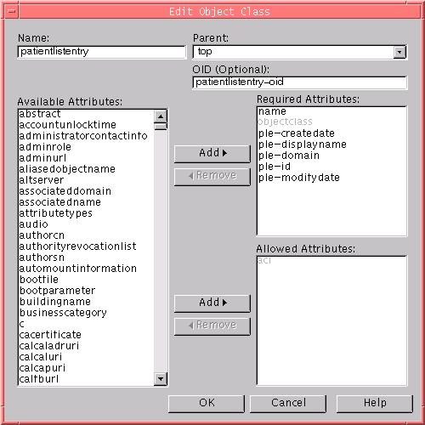

patlist
Each ‘patlist’ Class in LDAP denotes a PatientList Object persisted in LDAP. It has a one-to-one mapping to the com.carescience.cde.plist.PatientList Class.

It extends from LDAP’s base ‘top’ Class and has an optional Object identifier. It has two required and one optional attributes. The required attributes are name and pl-listName. The optional attribute is pl-listEntries.

These attribute and their types are described in the previous sections of this document.

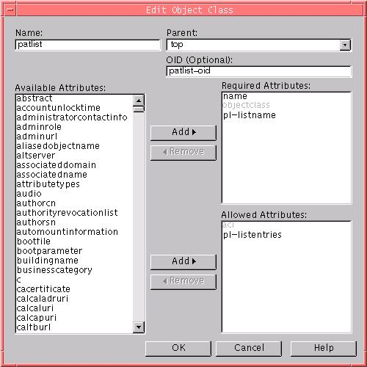

patientListMediator
The ‘patientlistmediator’ Class in LDAP denotes an Object which holds information about the various PatientList Objects and their names persisted in LDAP for a particular user.

It extends from LDAP’s base ‘top’ Class and has an optional Object identifier. It has a required attribute called name and an optional attribute called pListNames.

These attribute and their types are described in the previous sections of this document.

Create Single Virtual Admin User in LDAP

TECH SERVICES NOTE: This section is specifically for tech services.

In order to create and maintain the LDAP Objects needed to provide the Patient history list feature, we create a ‘single virtual admin user’ entry in the corresponding LDAP. This is usually created in the ‘ou=People’ level of the LDAP root directory.

The PatientListMediator service and it’s support Classes use this admin user credentials to connect and persist Objects in LDAP.

The details of this admin user need be mentioned in the CDE.properties file to be used by the PatientListMediator.

Ex:
uid=testuser, ou=People, o=carescience.com
and the user’s corresponding password need to be mentioned in the properties file.

LDAP Configuration for Access (ACI)

TECH SERVICES NOTE: This section is specifically for tech services.

In order for the ‘single virtual admin user’ described in the above section to be able to access and write to the user’s directory space, we need to assign an ACI to each of the lowest level nodes in the directory denoting a user workspace.

Ex:
If the user “uid=demoUser, ou=mySpace.myDomain.com, o=myDomain.com, o=LDAP Root” need to be assigned an ACI, then

LDAP Root
|
- myDomain.com
|
  - mySpace.myDomain.com
|
- demoUser

The ACI needs to be applied to the node indicated in bold in the above directory tree.

This can avoid a few potential security issues to the LDAP Directory Server.

The ACI to be used for this purpose is shown below. The admin user is assumed to be testuser in the ou=People node of the LDAP root directory.

Generic ACI:

(target="ldap:///<USER DN>")(targetattr="*")(version 3.0; acl "PatientListMediator"; allow (all) userdn = "ldap:///uid=testuser, ou=People, o=LDAPROOT";)

Ex:
for tkwan@santabarbara.sansum.com, the ACI would be

(target="ldap:///uid=tkwan,ou=santabarbara.sansum.com,o=sansum.com,o=carescience.com")(targetattr="*")(version 3.0; acl "PatientListMediator"; allow (all) userdn = "ldap:///uid=testuser, ou=People, o= LDAPROOT ";)

Create UserPerson Object and Attributes in LDAP (CDE 2.1)

TECH SERVICES NOTE: This section is specifically for tech services.

There are 3 new attributes (in the new object “userperson” that is a child of inetorgperson) that control the behavior and security of CDE:

Attribute | Syntax
isConsumer | Integer
isClinicianAdmin | Integer
personId | Case Exact Match

To add to an account:
1 Use Advanced... Show All Attributes and added the object class userperson under inetorgperson
2 Edit the three attributes.
For isConsumer and isClinicianAdmin, 0=false and 1=true
The personId is only applicable if (isConsumer()).

ICS Event Logging
The ICS requires that particular activities generated from either User or BackEnd services get logged for auditing and query purposes.

For this version, logging will be done for only the current events that existed in the previous versions. These are
- CorrelationSystem – duplicateFoundDuringAdd
- CorrelationSystem – similarFoundDuringAdd
- CorrelationSystem – expiredPersonFoundDuringAdd

- DatabaseServices – personAdded
- DatabaseServices – personUpdated
- DatabaseServices – personRemoved

Design Components

Logging events will consist of the following new components:

- com.carescience.utility.IcsEventLogger
- com.carescience.utility.IcsEvent

Components needed to be updated:

- IcsSql.xml: Contains SQL for inserting log records into database
- IdentityService: instantiates IcsEventLogger in constructor
- PersonIdService: instantiates IcsEventLogger in constructor

Class Design

All referenced classes are in Figure 2.1 below.

com.carescience.utility.IcsEventLogger
This new class will implement CorrelationSystemListener and DatabaseServicesListener, and register with the CorrelationSystem and DatabaseServicesJdbc instances.

This class is instantiated in the two public service classes: IdentityService and PersonIdService. Calling functionality outside of these will not log records.

On an event, it will create an IcsEvent and persist it.
com.carescience.utility.IcsEvent
Is a single instance of an event.

Will use the standard JdbcHelper class to obtain a database connection using the standard ICS schema and on a persist() will insert a record into the table.

This class contains constants for event_type as well as field positioning information for prepared statements from the IcsSql.xml.

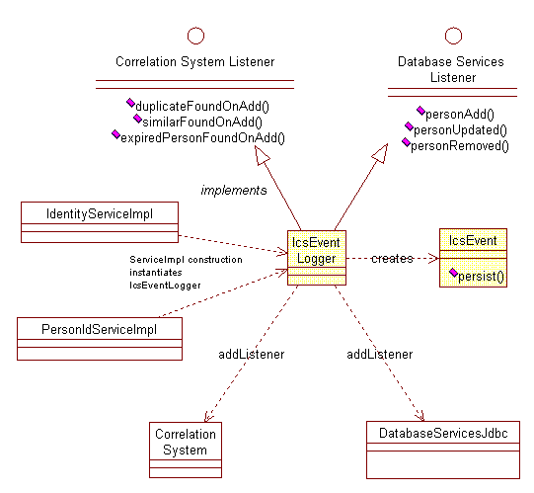

ICS_EVENT_LOG Table

Will store information relevant to the current event.

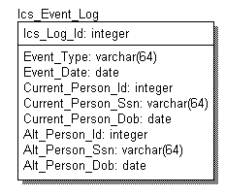

Description of fields

Ics_Log_Id: Unique ID of the LOG record
Event_Type: IcsEventLogger.DUPFOUND_ONADD (duplicate found)
IcsEventLogger.SIMFOUND_ONADD (similar match found)
IcsEventLogger.EXPFOUND_ONADD (expired person found)
IcsEventLogger.ADD
IcsEventLogger.UPDATE
IcsEventLogger.REMOVE
Event_Date: Date record was logged (inserted)
Current_Person: Attributes of the Person object being worked on
Alt_Person: Attributes of an optional Alternate Person being compared to.
Used for DUPFOUND and SIMFOUND.

ILS – Installation Instruction

create 2 directories, ‘CareScience’ and ‘apache-tomcat’, on the target host

- under directory 'CareScience':

1) In directory ‘CareScience/bin’,

customize the path and classpath variables in batch file ‘ilslauncher.bat’ (on windows platforms) or shell file 'ilslauncher.sh' (on linux/unix platforms)

2) In directory ‘CareScience/config’,

copy 2 properties files, 'CDEprops.xml' and 'cts.xml', into this directory and customize the properties in file 'CDEprops.xml'

3) In directory ‘CareScience/lib’,

copy the following jar files into this directory,
oojava.jar, classes12.zip, jcert.jar, jnet.jar, jsse.jar, xerces.jar, xalan.jar

Note: make sure the classpath in both 'ilslauncher.sh' and 'CDEprops.xml' point to 'apache-tomcat/webapps/IlsWebService/WEB-INF/classes' under tomcat-4.0 instead of IBM's wstk.

- under directory ‘apache-tomcat’
‘apache-tomcat’ is the installation of tomcat server 4.0 or higher:

- In directory 'apache-tomcat/bin',

modify batch file ‘catalina.bat’ (on windows platforms) or shell file 'catalina.sh' (on linux/unix platforms) to add the following system properties on the command lines for starting catalina:

-Dservice.hil.logger=/opt/CareScience/config/CDEprops.xml
-Djava.security.policy=/usr/jini1_1/policy/policy.all
-Dcom.carescience.xmlPropFile="/opt/CareScience/config/CDEprops.xml

- In directory 'apache-tomcat/lib',

copy the following jar files into this directory,

axis, clutil, commons-logging, jaxrpc,
log4j-core, tt-bytecode, wsdl4j, xerces,
jini-core, jini-ext, sun-util, syslog

- In directory ‘apache-tomcat/webapps/IlsWebService'

copy 2 deployment files, 'deploy.sh' and 'deploy.wsdd’, into this directory and customize the setup in file 'deploy.sh'

- in subdirectory 'apache-tomcat/webapps/IlsWebService/WEB-INF/classes'

install all of the java class files for CDE2.0 here

- in subdirectory 'apache-tomcat/webapps/IlsWebService/WEB-INF/lib’

copy the same jar files at the step (2) into this directory too

Summary of Setup Files That Need to Be Customized
Name(Windows/Unix) Location Description

Ilslauncher.bat/ CareScience/bin ILS startup script
ilslauncher.sh

CDEprops.xml Carescience/config ILS properties conf. file

catalina.bat apache-tomcat/bin tomcat startup script
catalina.sh

deploy.sh apache-tomcat/webapps/IlsWebService IlsWebService deploy script
deploy.wsdd apache-tomcat/webapps/IlsWebService IlsWebService deploy descriptor

Properties Files Setup –
The Information Locator Service (ILS) uses a configuration file to define it’s operation, performance, and administration. This file is located at …\CareScience\config\CDEprops.xml. CDEprops.xml contains seven segments. These segments are defined below.

- CONTACTS
- SECURITY
- SERVICE_PROPS
- SPACE_PROPS
- SVC_BROKER_PROPS
- CMND_MSGS
- STATUS_MESSAGES
- SYSTEM_PROPS

<CONTACTS>
This segment defines the contact information of the contact person at the facility. This information will be displayed to the user in the event the Organizations CDR is unavailable.

<CONTACTS>
<CONTACT_NAME>Dr. Bob</CONTACT_NAME>
<CONTACT_ADDRESSES
ADDRESS1 = "address #1"
ADDRESS2 = "address #2"
ADDRESS3 = "address #3"
CITY = "San Francisco"
STATE = "CA"
ZIP = "12345"/>
<CONTACT_PHONES
PHONE_COUNTRY_CODE = "001"
PHONE_AREA_CODE = "415"
PHONE_NUMBER = "555-1212"
EXTENSION = "123"/>
<CONTACT_EMAIL>drbob@hospital.com</CONTACT_EMAIL>
</CONTACTS>

<SECURITY_PROPS>
The information in this segment is used to create SSL connections with remote systems.

KEYSTORE_LOC – The full path and name of the keystore which holds your server certificate.
KEYSTORE_PWD – The password of the keystore.
KEY_PWD - The password of the private key.

<SECURITY_PROPS>
<CERTIFICATE_LOC
KEYSTORE_LOC = "C:\projects\cde1.2\security\cde.ks"
KEYSTORE_PWD = "password"
KEY_PWD = "password"/>
</SECURITY_PROPS>

<SERVICE_PROPS>
This segment defines the values that ILS will use when interacting with other ILS nodes.

GROUP_ID – The group name for the service
ILS_HOST – The FQDN (Fully Qualified Domain Name) of the service
ILS_SERVICE_PROVIDER – FQDN of the host publishing the web service.
ILS_SERVICE_NAME – Name of the web service (This should not change it should always be “IlsWebService”).

<SERVICE_FILES>
This segment is not currently being used.

PATH_TMP
PATH_LOG (Use default)
PATH_BIN

<HTTP_CONF>
This segment is used exclusively be JINI. JINI ships with a light-weight http daemon (web server). JINI operates by downloading objects via http. With the current architecture this downloading of objects is STRICTLY internal. This light-weight webserver can be set to any port that is not being used.

HTTP_HOST – The IP or FQDN of the machine.
HTTP_PORT – The port that this http daemon is listening on.

<SERVICE_PROPS
GROUP_ID = "incare.care.com"
ILS_HOST = "incare.care.com"
ILS_SERVICE_PROVIDER=" incare.care.com"
ILS_SERVICE_NAME="IlsWebService">

<SERVICE_FILES
PATH_TMP = "string"
PATH_LOG = "string"
PATH_BIN = "string"/>
<HTTP_CONF
HTTP_HOST = "incare.care.com"
HTTP_PORT = "8080"/>
</SERVICE_PROPS>

<SPACE_PROPS>
These values should not be changed.

<SPACE_PROPS>
<LIMITS
SPA_FOREVER = "99999999"
SPA_MAX_WAIT_TIME = "2500"
SPA_MAX_DISC_ATTEMPTS = "900"
SPA_MAX_TRIES = "600"
SPA_MAX_MATCHES = "10"/>
<SPACES
REQUEST_SPACE_NAME = "SPACE_REQ_"
RESPONSE_SPACE_NAME = "SPACE_RES_"/>
</SPACE_PROPS>

<CMND_MSGS>
These values should not be changed

<CMND_MSGS
SERVICE_START = "SERVICE_START"
SERVICE_STOP = "SERVICE_STOP"
SERVICE_EXIT = "SERVICE_EXIT"/>

<STATUS_MESSAGES>
These values should not be changed

<STATUS_MESSAGES
SERVICE_SUCCESS = "SERVICE_SUCCESS"
SERVICE_INCOMPLETE = "SERVICE_INCOMPLETE"
SERVICE_FAILURE = "SERVICE_FAILURE"/>

<SYSTEM_PROPS>
This segment defines how the system will publish Lab data.

SYSTEM_NAME

SYSTEM_TYPE – Set to “Lab”

WEB_APP
This segment defines the URI that will publish the requested data.

WEBHOST – The webhost of the URI
WEBPORT – The port of the URI
FILENAME – The Servlet, ASP, CGI, etc. that publishes the data.

URI_PARAMS
This is a repeatable segment that defines the URI parameters.

LITERAL – This defines weather the param should be taken as literal (static) or not.

INTERFACE
This segment defines how ILS will connect/query the CDR.

INTERFACE_TYPE
Should be defined as one of the three: JAVA, XML or HL7.

JAVA_INTERFACE
This segment defines the interface for: com.carescience.cde.ils.adapters.CdrAdapter or a custom Interface defined by the organization.

INTERFACE_FILENAME – Name of the Class.
DB_DRIVER – Database Driver
DB_URL – The connection string to the CDR.
DB_UNAME – User name
DB_PWD – Password
INTERFACE_PATH – The path of the Interface.

SQL – The SQL statement

HL7_INTERFACE
This segment defines the interface for: com.carescience.cde.ils.adapters.CdrAdapterHTTP.

HOST_IP_ADDRESS – Host address
SOCKET – Port

XML_INTERFACE
This segment defines the interface for: com.carescience.cde.ils.adapters.CdrAdapterSocket.

XML_OUTFILE – Path/name of the out file. Used for debugging.
XML_URI – The URI to post the request.
XML_SYSTEM – Name of the organization

<SYSTEM_PROPS
SYSTEM_NAME = "Care Labs">

<SYSTEM_TYPE>Lab</SYSTEM_TYPE>
<WEB_APP
WEBHOST = "incare.care.com"
WEBPORT = "443"
FILENAME = "labServlet">

<URI_PARAMS LITERAL = "N">patId</URI_PARAMS>
<URI_PARAMS LITERAL = "N">recId</URI_PARAMS>
<URI_PARAMS LITERAL = "Y">path=/xsl/results.xsl</URI_PARAMS>
</WEB_APP>
<INTERFACE>
<INTERFACE_TYPE>JAVA</INTERFACE_TYPE>
<JAVA_INTERFACE
INTERFACE_FILENAME = "CdrAdapter"
DB_DRIVER = "oracle.jdbc.driver.OracleDriver"
DB_URL = "jdbc:oracle:thin:@db-host:1521:CDR"
DB_UNAME = "uname"
DB_PWD = "password"
INTERFACE_PATH = "com.carescience.cde.ils.adapters">

<SQL>SELECT * FROM table WHERE ? = ? SQL>
</JAVA_INTERFACE>
<HL7_INTERFACE
HOST_IP_ADDRESS = " 10.10.10.3"
SOCKET = "250">
</HL7_INTERFACE>
<XML_INTERFACE
XML_OUTFILE = "d:\temp\out.xml"
XML_URI = "http://10.10.10.3/soap/DisplayLabs.asp"
XML_SYSTEM = "Care Labs”>
</XML_INTERFACE>
</INTERFACE>
</SYSTEM_PROPS>

<LAUNCHER_PROPS>
ILS is made up of several different services. This segment defines how each service runs.

HTTP
HTTP_DISABLE – Disables the JINI http daemon. Set to either “Y” or “N”.
HTTP_JVMOPT – Custom parameters to pass to the JVM
HTTP_FILE – Path to tools.jar in ….\jini1_1\lib\
HTTP_ROOT – set to the lib directory of the JINI installation
HTTP_WAIT – Wait time in miliseconds.

RMID
RMID_OPT – Custom parameters to pass to the JVM
RMID_POLICY – The policy file to use with the JVM
RMID_LOG – Location and name of the log file.
RMID_WAIT – Wait time in miliseconds.

LOOKUP
LKUP_JVMOPT – Custom parameters to pass to the JVM
LKUPS_POLICY – The policy file to use with the JVM
LKUPS_FILE – Full path to reggie.jar
LKUPS_CODEBASE – set to "reggie-dl.jar"
LKUPS_LOG – Location and name of the log file.
LKUPS_WAIT – Wait time in miliseconds.

TXN
TXN_JVMOPT – Custom parameters to pass to the JVM
TXN_POLICY – The policy file to use with the JVM
TXN_NAME – Set to "TransactionManager"
TXN_FILE – Full path to mahalo.jar
TXN_CODEBASE – Set to "mahalo-dl.jar"
TXN_LOG – Location and name of the log file.
TXN_WAIT – Wait time in miliseconds.

REQSP
REQSP_JVMOPT – Custom parameters to pass to the JVM
REQSP_POLICY – The policy file to use with the JVM
REQSP_NAME – Name of the request space
REQSP_CODEBASE – Set to "outrigger-dl.jar"
REQSP_FILE – Full path to transient-outrigger.jar
REQSP_LOG – Location and name of the log file.
REQSP_WAIT – Wait time in miliseconds.

RESSP
RESSP_JVMOPT – Custom parameters to pass to the JVM
RESSP_POLICY – The policy file to use with the JVM
RESSP_NAME – Name of the response space
RESSP_CODEBASE – Set to "outrigger-dl.jar"
RESSP_FILE – Full path to transient-outrigger.jar
RESSP_LOG – Location and name of the log file.
RESSP_WAIT – Wait time in miliseconds.

ILS
ILS_JVMOPT – Custom parameters to pass to the JVM
ILS_POLICY – The policy file to use with the JVM
ILS_CODEBASE Set to “HilService-dl.jar”
ILS_FILE – Set to "com.carescience.cde.ils.HilService"
ILS_PROPS – Full path of CDEprops.xml
ILS_WAIT – Wait time in miliseconds.
ILS_CLSPATH – Classpath

RMIREGISTRY
RMIREGISTRY_OPT – Custom parameters to pass to the JVM
RMIREGISTRY_WAIT – Wait time in miliseconds.

<LAUNCHER_PROPS>
<HTTP
HTTP_DISABLE = "N"
HTTP_JVMOPT = ""
HTTP_FILE = "C:\jini1_1\lib\tools.jar"
HTTP_ROOT = "C:\jini1_1\lib"
HTTP_WAIT = "10000"/>
<RMID
RMID_OPT = ""
RMID_POLICY = "C:\jini1_1\policy\policy.all"
RMID_LOG = "C:\jini1_1\tmp\rmiD.log"
RMID_WAIT = "10000"/>
<LOOKUP
LKUP_JVMOPT = ""
LKUPS_POLICY = "C:\jini1_1\policy\policy.all"
LKUPS_FILE = "C:\jini1_1\lib\reggie.jar"
LKUPS_CODEBASE = "reggie-dl.jar"
LKUPS_LOG = "C:\jini1_1\tmp\lku.log"
LKUPS_WAIT = "20000"/>
<TXN
TXN_JVMOPT = ""
TXN_POLICY = "C:\jini1_1\policy\policy.all"
TXN_NAME = "TransactionManager"
TXN_FILE = "C:\jini1_1\lib\mahalo.jar"
TXN_CODEBASE = "mahalo-dl.jar"
TXN_LOG = "C:\jini1_1\tmp\tnx.log"
TXN_WAIT = "20000"/>
<REQSP
REQSP_JVMOPT = ""
REQSP_POLICY = "C:\jini1_1\policy\policy.all"
REQSP_NAME = "SPACE_REQ_"
REQSP_CODEBASE = "outrigger-dl.jar"
REQSP_FILE = "C:\jini1_1\lib\transient-outrigger.jar"
REQSP_LOG = "C:\jini1_1\tmp\reqsp.log"
REQSP_WAIT = "10000"/>
<RESSP
RESSP_JVMOPT = ""
RESSP_POLICY = "C:\jini1_1\policy\policy.all"
RESSP_NAME = "SPACE_RES_"
RESSP_CODEBASE = "outrigger-dl.jar"
RESSP_FILE = "C:\jini1_1\lib\transient-outrigger.jar"
RESSP_LOG = "C:\jini1_1\tmp\ressp.log"
RESSP_WAIT = "10000"/>
<ILS
ILS_JVMOPT = ""
ILS_POLICY = "C:\jini1_1\policy\policy.all"
ILS_CODEBASE = "HilService-dl.jar"
ILS_FILE = "com.carescience.cde.ils.HilService"
ILS_PROPS = "C:\projects\cde1.2\config\CDEprops.xml"
ILS_WAIT = "5000"
ILS_CLSPATH = "C:\projects\cde1.2\output;C:\jini1_1\lib\jini-core.jar;C:\jini1_1\lib\jini-ext.jar;C:\jini1_1\lib\sun-util.jar;C:\projects\cde1.2\lib\jsse.jar;C:\projects\cde1.2\lib\jnet.jar;C:\projects\cde1.2\lib\jcert.jar;c:\projects\Cde1.2\lib\classes12.zip;c:\projects\Cde1.2\lib\xerces.jar;c:\projects\Cde1.2\lib\syslog.jar"/>
<RMIREGISTRY
RMIREGISTRY_OPT = ""
RMIREGISTRY_WAIT = "10000"/>
</LAUNCHER_PROPS>

<Syslog>
Defines the ILS log files. You only need to edit the values in blue. <baseName>.

<Syslog defaultMask="DEBUG">
<Logger name="myPrintWriterLog"
class="com.protomatter.syslog.PrintWriterLog">
<stream>System.out</stream>
<Policy class="com.protomatter.syslog.SimpleLogPolicy">
<channels>ALL_CHANNEL</channels>
<logMask>INHERIT_MASK</logMask>
</Policy>
<Format class= "com.protomatter.syslog.SimpleSyslogTextFormatter">
<showChannel>true</showChannel>
<showHostName>false</showHostName>
</Format>
</Logger>

<Logger name="myLengthRolloverLog"
class="com.protomatter.syslog.LengthRolloverLog">
<Policy class= "com.protomatter.syslog.SimpleLogPolicy">
<channels>ILSSYS</channels>
<logMask>INHERIT_MASK</logMask>
</Policy>
<Format class= "com.protomatter.syslog.SimpleSyslogTextFormatter">
<showChannel>true</showChannel>
<showHostName>false</showHostName>
</Format>
<baseName> c:\projects\cde1.2\logs\ILSSYS_</baseName>
<extension>.log</extension>
<rollSize>4096000</rollSize>
<autoFlush>true</autoFlush>
</Logger>

<Logger name="TXNLengthRolloverLog"
class="com.protomatter.syslog.LengthRolloverLog">
<Policy class="com.protomatter.syslog.SimpleLogPolicy">
<channels>ILSTXN</channels>
<logMask>INHERIT_MASK</logMask>
</Policy>
<Format class= "com.protomatter.syslog.SimpleSyslogTextFormatter">
<showChannel>true</showChannel>
<showHostName>false</showHostName>
</Format>
<baseName>C:\projects\cde1.2\logs\ILSTXN_</baseName>
<extension>.log</extension>
<rollSize>4096000</rollSize>
<autoFlush>true</autoFlush>
</Logger>
</Syslog>

IlsLauncher.bat
Edit this file to match your local system.

set JINIHOME=C:\jini1_1
set CAREHOME=C:\CareScience

set JINIJARS=%JINIHOME%\lib\jini-core.jar;%JINIHOME%\lib\jini-ext.jar;%JINIHOME%\lib\sun-util.jar
set JSSEJARS=%CAREHOME%\lib\jsse.jar;%CAREHOME%\lib\jcert.jar;%CAREHOME%\lib\jnet.jar
set CAREJARS=%CAREHOME%\cs_ils.jar; %CAREHOME%\cs_utils.jar;%CAREHOME%\cs_common.jar;%CAREHOME%\lib\xerces.jar;%CAREHOME%lib\syslog.jar

java -cp %CAREJARS%;%JINIJARS%;%JSSEJARS% -Dcom.carescience.xmlPropFile=%CAREHOME%\config\CDEprops.xml -Dcde.properties.file=%CAREHOME%\config\CDE.properties com.carescience.utility.admin.IlsLauncher

How to setup tomcat to work with other application servers
- Refer to the application server’s setup document on how to configure it to forward the requests for IlsWebService to the tomcat instance. The following links are references for setting up Apache, IIS and Netscape servers with tomcat,

http://jakarta.apache.org/tomcat/tomcat-4.0-doc/proxy-howto.html
http://jakarta.apache.org/tomcat/tomcat-4.0-doc/config/warp.html
http://jakarta.apache.org/tomcat/tomcat-4.0-doc/config/ajp.html

http://jakarta.apache.org/tomcat/tomcat-3.3-doc/tomcat-iis-howto.html
http://jakarta.apache.org/tomcat/tomcat-3.3-doc/tomcat-netscape-howto.html

- Following the link below to configure the tomcat server for integrating it with a web server,

http://jakarta.apache.org/tomcat/tomcat-4.0-doc/proxy-howto.html

Document about how to set up Tomcat 4.0 with IIS web server on windows platform,

http://members.ozemail.com.au/~lampante/howto/tomcat/iisnt/index.html

Integration Options
The Locator Service currently supports three integration options. First, a Java interface can be implemented as defined below.

Locator Service Java Interface
Description
The Locator Service can be integrated using a Java Interface implemented by the vendor or the customer. This interface is defined below in Definition. The function of the interface is to return a list of parameters that must be passed to the web interface in order to calculate the URL. Input parameters will be sent from the locator service. The key/value pairs for the parameters are returned back to the locator service which will report back to the originating service. The interface returns an array of type HashMap so that the key/value pairs for each record can be returned.
The interface will receive the criteria for a query to determine what records are desired. A connection to the source database needs to be made to determine the key values that a web application can use to access the records that meet the search criteria.

Definition
package com.carescience.hils;
/**
* Title: Locator Service Project; External Locator Interface
* Description: Defines an interface to be implemented on an
* external system for integration
* with the locator service.
* Copyright: Copyright (c) 2001
* Company: CareScience, Inc.
* @version 1.0
*/
public interface ExternalLocator {
public HashMap[] getLocators(Person aPatient,
Person aProvider,
String[] infoTypes,
String[] infoClasses,
String[] encounterIDs,
Date startDateRange,
Date endDateRange) throws RemoteException;
}
The Java interface that must be implemented is defined below.

Registration with Properties file
The interface must be registered in the Locator Startup properties file. The following is an example of the properties file configured to use the Java Interface ().

<?xml version="1.0" ?>
<CS_STARTUP>
<CS_LOCATOR>
<SERVICE_PROPS>
<CAREHOME>com.carescience</CAREHOME>
<HTTPHOST>wwwServer</HTTPHOST>
<PORT>8081</PORT>
<GROUP>com.hosp</GROUP>
</SERVICE_PROPS>
<SYSTEM>
<SYSTEM_NAME>CCA</SYSTEM_NAME>
<SYSTEM_TYPE>LAB</SYSTEM_TYPE>
<WEB_APP>
<WEBHOST>www.hosp.com</WEBHOST>
<WEBPORT>443</WEBPORT>
<FILENAME>getLabInfo</FILENAME>
</WEB_APP>
<INTERFACE>
<INTERFACE_TYPE>Java</INTERFACE_TYPE>
<JAVA_INTERFACE>
<FILENAME>LocatorImpl.jar</FILENAME>
<INTERFACE_PATH>/opt/loc/lib</INTERFACE_PATH>
</JAVA_INTERFACE>
</INTERFACE>
</SYSTEM>
</CS_LOCATOR>
</CS_STARTUP>

Locator Service HL7 Definition
If selected the HL7 interface can be utilized in a TCP/IP, sockets based approach. In this method, a QRY event will be sent to the appropriate host and socket.
QRY Format
The user is interested in finding the location of records that meet the following criteria:
- Patient ID = 123454
- Type = Lab
- Class = Chemistry
- Description = null
- Start Date Range = 12/15/2000
- End Date Range = 3/15/2001
The query is made on 3/15/2001 at 10:12 am. An immediate response is requested. The quantity limited is unspecified.
MSH|^-|&|ICU| |LAB01| | | |QRY^Q01|MSG00001|P|2.3<cr>
QRD|200103151012|D|I|4387| | | |123454|Chemistry |Lab| |ALL<cr>
QRF| |200012150000|200103151012|Chemistry;Lab| | | | |<cr>

RSP format
The Response to the above query may appear as follows:
MSH|^-|&|LAB01| |ICU| | | |DSR|ZXT23461|P|2.3<cr>
MSA|AA|MSG000001P<cr>
QRD|200103151012|D|I|4387| | | |123454|Chemistry |Lab| |ALL<cr>
DSP| | |patID=123454;recID=239482
DSP| | |patID=123454;recID=098342
DSP| | |patID=123454;recID=234255
DSP| | |patID=123454;recID=012211
DSP| | |patID=123454;recID=098234
DSP| | |patID=123454;recID=234211
DSP| | |patID=123454;recID=012098

Properties for HL7 interface
The interface properties for the HL7 interface differ from those used for the Java interface.
<?xml version="1.0" ?>
<CS_STARTUP>
<CS_LOCATOR>
<SERVICE_PROPS>
<CAREHOME>com.carescience</CAREHOME>
<HTTPHOST>wwwServer</HTTPHOST>
<PORT>8081</PORT>
<GROUP>com.hosp</GROUP>
</SERVICE_PROPS>
<SYSTEM>
<SYSTEM_NAME>CCA</SYSTEM_NAME>
<SYSTEM_TYPE>LAB</SYSTEM_TYPE>
<WEB_APP>
<WEBHOST>www.hosp.com</WEBHOST>
<WEBPORT>443</WEBPORT>
<FILENAME>getLabInfo</FILENAME>
</WEB_APP>
<INTERFACE>
<INTERFACE_TYPE>HL7</INTERFACE_TYPE>
<HL7_INTERFACE>
<HOSTIP>127.0.0.1</HOSTIP>
<INTERFACE_SOCKET>9091</INTERFACE_SOCKET>
</HL7_INTERFACE>
</INTERFACE>
</SYSTEM>
</CS_LOCATOR>
</CS_STARTUP>

Locator Service HTTPS Post of Locator Information
This option allows an external system to post XML messages containing the Locator information to the Locator Service which then manages the storage and retrieval of this information. This option requires that the external system handle add transactions (new information), plus updates (e.g. a host name change) and deletes. This option will also require that sufficient disk space be made available to store the locator information. While each record is very small, the potential for this data to grow is very real. CareScience, has recorded average transaction volumes of approximately 8.5 million records per year per organization. This average translates into roughly .75 GB of locator per year. Actual data size may vary based on the length of the URL as well.

HTTP Post of Message
The add, update, delete messages are posted to the locator service via http. The envelope for the message should include the following:
POST http://127.0.0.1:9090/path HTTP/1.0
Connection: Keep-Alive
Content-type:application/vnd.loc;version=”1.0”;charset=”UTF=8”
Content-Length:nnnn

Properties for HTTP Post Interface
The Post interface uses another set of parameters as described below.
<?xml version="1.0" ?>
<CS_STARTUP>
<CS_LOCATOR>
<SERVICE_PROPS>
<CAREHOME>com.carescience</CAREHOME>
<HTTPHOST>wwwServer</HTTPHOST>
<PORT>8081</PORT>
<GROUP>com.hosp</GROUP>
</SERVICE_PROPS>
<SYSTEM>
<SYSTEM_NAME>CCA</SYSTEM_NAME>
<SYSTEM_TYPE>LAB</SYSTEM_TYPE>
<WEB_APP>
<WEBHOST>www.hosp.com</WEBHOST>
<WEBPORT>443</WEBPORT>
<FILENAME>getLabInfo</FILENAME>
</WEB_APP>
<INTERFACE>
<INTERFACE_TYPE>HL7</INTERFACE_TYPE>
<POST_INTERFACE>
<INTERFACE_PATH>/opt/locdata</ INTERFACE_PATH >
<FILENAME>locators</FILENAME>
</POST_INTERFACE>
</INTERFACE>
</SYSTEM>
</CS_LOCATOR>
</CS_STARTUP>

Automated Polling
The Automated Polling service performs ILS queries every hour on selected Patient Lists stored on an LDAP server. The Poller is a stand alone application that runs independently of Weblogic Server and the ILS. When the service is executed it will perform the polling tasks approximately 10min. before the hour and repeat these tasks every subsequent hour until killed.

LDAP schema for Polling
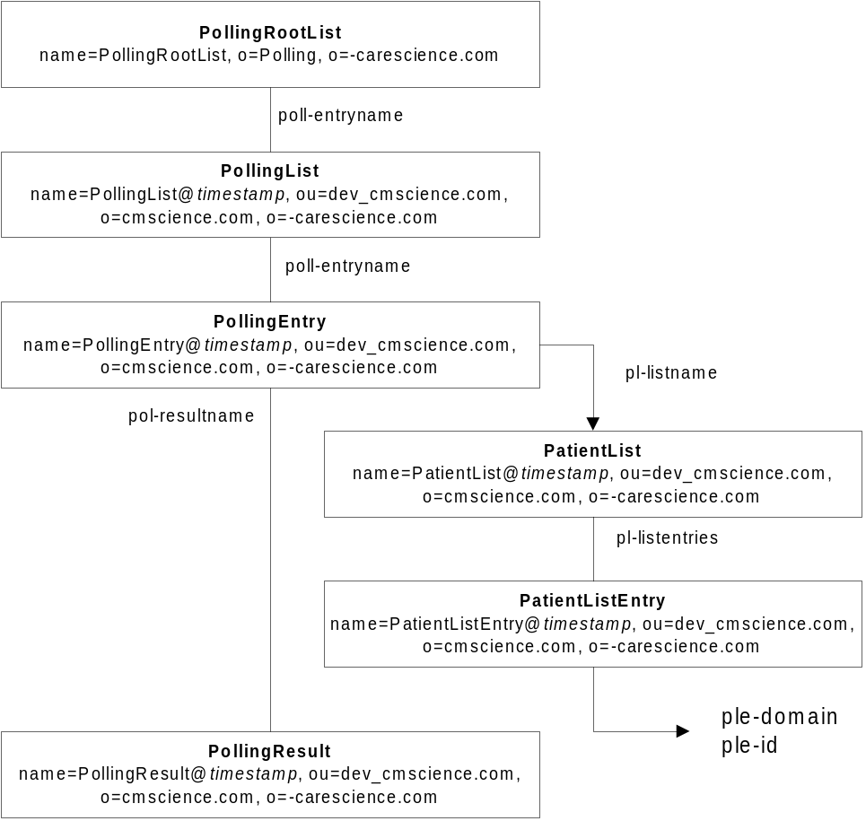

The polling tasks are as follows:

- Retrieve all PollingLists from the PollingRootList
- Retrieve each PollingEntry from each PollingList
- For each PollingEntry get the associated PatientList
- Retrieve the PatientListEntries associated with the PatientList
- For each PatientList perform an ILS query based on the domainId's and patientId's in each PatientListEntry
- Update the LDAP server with the results of the ILS query by modifying or creating PollingResult entries and associate these new entries with the PollingEntry

Retrieve all the PollingLists from the PollingRootList
The Distinguished Name (DN) for the PollingRootList is: name=PollingRootList, o=Polling, o=carescience.com. This entry contains a list of all PollingLists on the LDAP server. The value in poll-entryname is the full DN to the PollingList entry.

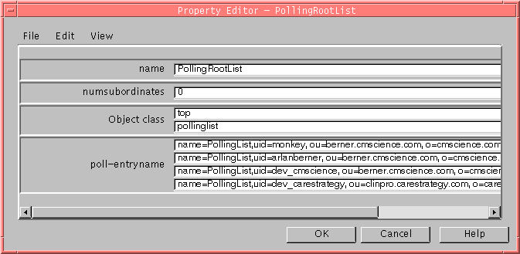

For each PollingList entry the Poller performs the following:

Retrieve each PollingEntry from the PollingList
There is one PollingList per user. The PollingList contains a list of all PollingEntries for this user.
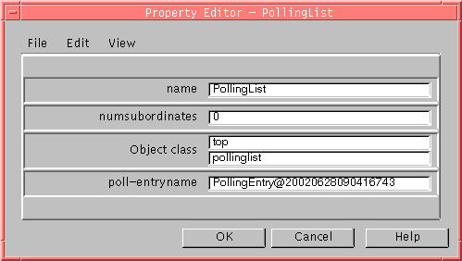

For each PollingEntry the Poller performs the following:

Get the associated PatientList
Each PollingEntry corresponds to one PatientList. The PollingEntry defines the polling information for it's associated PatientList. e.g. polling frequency, last login date, last polled date, etc…

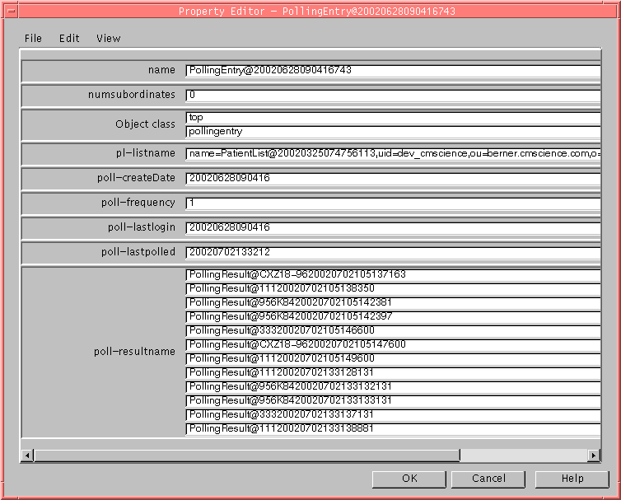

Retrieve the PatientListEntries associated with the PatientList
Each PatientList contains a list of PatientListEntries. These entries contain the information about a patient that is needed to query the ILS. Such as: patientId and domainId.

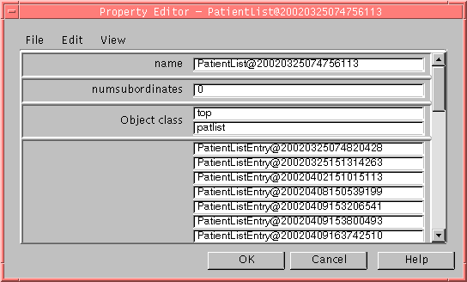

For each PatientList perform an ILS query based on the domainId's and patientId's in each PatientListEntry
Retrieve the patientId and domainId from the PatientListEntry.
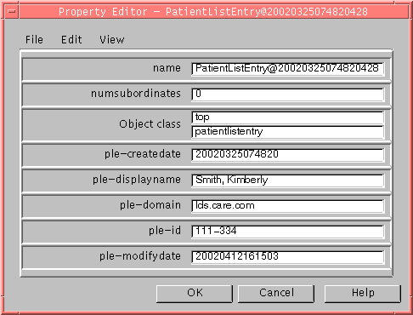

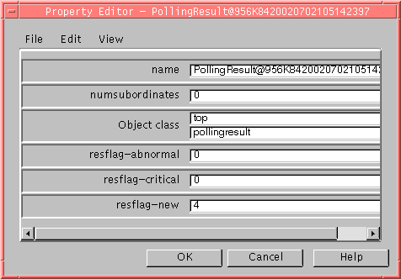
Update the LDAP server with the results of the ILS query by modifying or creating PollingResult entries and associate these new entries with the PollingEntry.

Starting the Poller
The Poller is started by executing startPoller.bat. In order to run this program setEnv.bat needs to be configured with the correct paths. The Poller will wait until 10 minutes before the hour and then perform the polling tasks. If the current time is between the 10 minute period it will execute immediately.

Certificates

Certificate Request

Created using the java swing application. Dialog boxes that walk the user through setting up a certificate request.

KeytoolScreen.java
Prompts the user if they want to create a keystore.
Yes – takes the user to the next screen.
No-closes the window and shuts down the process.

KeytoolScreen1.java
Collects the needed fields and generates the keys and passwords.
Asks for the file location.

KeytoolScreen2.java
Collects user information.
Once the user hits ‘OK’, the program creates the command lines and sends over to MS Dos prompt (this will take several seconds).

KeytoolScreen3.java
Send the .csr file to CareScience(Ken Emery).
Get the user name and email address.

Once the user has received the certificate via email:
ImportCert.java
Imports the certificate sent from CareScience to the user’s specified location.

SSL/HTTPS in CDE
The CDE has used SSL/HTTPS pretty much exclusively as part of the ILS. With 2.0 and 2.1, the ILS was changed to use the Apache Axis SOAP adapter and a new ResultServlet was created to proxy results from remote secure sites through our server. Both the ILS and the ResultServlet require client certificates be presented and the Axis SOAP code uses SSL directly without going through Java HttpsUrlConnections. All of these issues conspired together to require changes to and uniformity in the use and setup of secure connections within CDE.

Functional Flow

We need to define a Keystore (place where our private key and client certificate lives) and a Truststore (place where certificates of others we trust or Certificate Authority certs live) so that we can initiate an SSL connection, establish that we trust the remote site, and send them our client certificate that they trust. All of this needs to be established before any SSL/HTTPS connections are made.

Components

com.carescience.utility.SSLFactory
The SSLFactory class has been changed to encapsulate all of the setting and configuration of the SSL stuff for use by CDE. SSLFactory has been changed to extend SSLSocketFactory so that we can implement the default SSLSocketFactory for all SSL and HTTPS connections. For now, the only public method of interest is init(). This method must be called at least once before using any SSL or HTTPS stuff. Subsequent calls to init() do nothing. The init() method additionally returns an SSLSocketFactory which can be used directly by any code doing SSL stuff. This is generally not needed since the default SSLSocketFactory is now set to be our own.

com.carescience.cde.ils.IlsConnector
This class was changed to invoke SSLFactory.init().

com.carescience.cde.utility.ResultServlet
This class was changed to invoke SSLFactory.init().

Configuration
The new SSLFactory uses a single Java Key Store as both the Keystore and Truststore. This means that the CA certs and the private key and signed client certificate need to be in a single java key store. The only CA that should be present is our CA since we should only be trusting servers signed by us. If we later choose to trust any signer (Verisign, for example), we will need to add their CA certs to this key store.
Note: This no longer requires that the default java $JAVA_HOME/jre/lib/security/cacerts be updated with our CA. The code will no longer look to the default java cacerts for any CA certificate verification.

CDEprops.xml
The CDEprops.xml is really designed for ILS only, but for now it is also the place we keep the settings for the keystore path and keystore and key passwords. These will need to be set correctly in any CDE or ILS deployment.
The relevant configuration is in the SECURITY_PROPS section under CERTIFICATE_LOC. The three required settings are:

KEYSTORE_LOC | Path to the Java Key Store that contains the private key, signed client certificate and the CA
KEYSTORE_PWD | Password for the keystore. This may be entered plaintext, it will be encrypted when the system is run.
KEY_PWD | Password for the private key. This may be entered plaintext, it will be encrypted when the system is run.

There is a default java key store as part of the release in the security directory. This contains the development CA and a private key and signed cert. This is only meant as an example and should be replaced with a product key store.

Future Work

The security settings now described in CDEprops.xml should be move to a more generalized location.

Weblogic CDE Default Settings

CDE 2.0 now employs BEA’s WebLogic 6.1 application server as its platform. This server supports web-based administration and configuration. Administration and configuration settings are stored in the WebLogic 6.1 configuration file at weblogic02:/bea/wlserver6.1/config/mydomain/config.xml. These properties include configurations for the CDE web application, startup services such as PIDS and IDS, HTTP/HTTPS listener port numbers, etc.

Servlet registration and mappings are stored in the web.xml file under the <CDE_web_application>/WEB-INF/ directory.

A detailed document about the default weblogic.properties (ver 5.1) can be found with the URL below,

http://www.weblogic.com/docs51/admindocs/properties.html

Based on the file from weblogic02, the following is a list of our customizations for CDE,

Customize the listening port to be 80,
weblogic.system.listenPort=80

Customize the system password, (this will change by client site – sample only)
weblogic.password.system=CareSci123

Enable the SSL feature and set the SSL listening port to be 443,
weblogic.security.ssl.enable=true
weblogic.system.SSLListenPort=443

Set the certificates for SSL
weblogic.security.clientRootCA=ca.pem
weblogic.security.certificate.authority=ca.pem
weblogic.security.certificate.server=cdeCert.pem
weblogic.security.key.server=weblogic02_carescience_com-key.der

Customize administrator info, (this will change by client site – example only)
weblogic.administrator.location=3600 Market Street, Philadelphia, PA
weblogic.administrator.name=Hugh MacMullen
weblogic.administrator.phone=1 215 387 9401

Customize the URL for help pages,
weblogic.system.helpPageURL=/opt/weblogic/myserver/public_html/docs51/adminhelp/

Customize the document root,
weblogic.httpd.documentRoot=/opt/weblogic/myserver/public_html/cde

Customize the servlet class path,
weblogic.httpd.servlet.classpath=/opt/CareScience/lib/cs_cde.jar:/opt/CareScience/lib/cs_cscr.jar:/opt/CareScience/lib/cs_ils.jar:/opt/weblogic/myserver/servletclasses:/opt/CareScience/lib/getLabServlet.jar

Add the JDBC and JMS connection pools, (For CareScience QA setup only – used for setting up internal ILS nodes)
weblogic.jdbc.connectionPool.ldsPool=\
url=jdbc:oracle:thin:cde_admin/cde_admin@test-oracle01:1521:ldev,\
driver=oracle.jdbc.driver.OracleDriver,\
initialCapacity=1,\
maxCapacity=30,\
capacityIncrement=1,\
allow=guest
weblogic.jdbc.TXDataSource.ldsPool=ldsPool
weblogic.allow.reserve.weblogic.jdbc.connectionPool.ldsPool= everyone

weblogic.jms.connectionPool=odsPool
weblogic.jdbc.connectionPool.odsPool=\
url=jdbc:oracle:thin:@demo-db01:1521:nwdr,\
driver=oracle.jdbc.driver.OracleDriver,\
initialCapacity=1,\
maxCapacity=30,\
capacityIncrement=1,\
props=user=area1;password=area1,\
allow=guest
weblogic.jdbc.TXDataSource.weblogic.jdbc.jts.odsPool=odsPool
weblogic.allow.reserve.weblogic.jdbc.connectionPool.odsPool= everyone

weblogic.jms.connectionPool=errorPool
weblogic.jdbc.connectionPool.errorPool=\
url=jdbc:oracle:thin:@demo-db01:1521:nwdr,\
driver=oracle.jdbc.driver.OracleDriver,\
initialCapacity=1,\
maxCapacity=30,\
capacityIncrement=1,\
props=user=area1;password=area1,\
allow=guest
weblogic.jdbc.TXDataSource.weblogic.jdbc.jts.errorPool= errorPool
weblogic.allow.reserve.weblogic.jdbc.connectionPool.errorPool= everyone

Customize the startup classes,
weblogic.system.startupClass.Syslog=com.protomatter.syslog.SyslogT3Startup
java.system.property.Syslog.config.xml=/opt/CareScience/config/Syslog.config.xml
weblogic.system.startupClass.idsImpl=com.carescience.cde.pids.IdentityServiceImpl
weblogic.system.startupClass.pidsImpl=com.carescience.cde.pids.PersonIdServiceImpl

Customize the shutdown classes,
weblogic.system.shutdownClass.Syslog=com.protomatter.syslog.SyslogT3Startup

Register the servlets for CDE,
weblogic.httpd.register.MPIServlet=com.carescience.http.MPIServlet
weblogic.httpd.register.MPITestServlet=com.carescience.http. test.MPITestServlet
weblogic.httpd.register.QueryServlet=com.carescience.http.QueryServlet
weblogic.httpd.initArgs.QueryServlet=hostname=cde.carescience. com
weblogic.httpd.register.RMITestServlet=com.carescience.http. test.RMITestServlet
weblogic.httpd.register.FindPersonServlet=com.carescience.http.test.FindPersonServlet
weblogic.httpd.register.ICSLog=com.carescience.http. ICSLogServlet
weblogic.httpd.register.GetLab = com.carescience.http.GetLabServlet

Set the application deployments for EJB and GUI,

weblogic.ejb.deploy=\
/opt/weblogic/myserver/ejb_exchange.jar,\
/opt/weblogic/myserver/ejb_cdr.jar

weblogic.httpd.webApp.cde=/opt/weblogic/myserver/public_html/ cde
weblogic.httpd.webApp.cde_admin=/opt/weblogic/myserver/public _html/cde_admin
weblogic.httpd.webApp.wdr=/opt/weblogic/myserver/public_html/ wdr

Compilation/Build & Start/Stop Procedures | Author | Reviewer

Startup/Stop Procedures for ICS
Since all the services in ICS are startup services of the underlying WebLogic Application Server, they startup and shutdown with the WebLogic Application Server.

Startup / Stop Procedures for ILS
Running the ILS installer will create a launcher script - …\CareScience\bin\Launch. Execute this script to start ILS services. This script can be modified by editing Launch.lax also in the bin directory. You can also start ILS by running ilslauncher.bat also located in the bin directory.

To stop ILS control+c (^c) in the console window.

Build Procedures for CDE
On a Unix environment, use the Make facility: <unix_host>:<CDE_root> make

For example, to build CDE 2.0 using the Makefile on weblogic02:
# cd /opt/cde
# make

On a Windows environment, use the CDE JBuilder project (CDE.jpr) to build CDE 2.0.

Known Exceptions | Author | Reviewer

GUI –

The following is a list of jsp pages with the exceptions to look for if they show up.

UpdatePatient.jsp
com.carescience.utility.JndiException in the PersonIdService method

ValidSessionChkBottom.jsp
java.lang.IllegalStateException

TreeTest.jsp
org.xml.sax.SAXException
java.io.IOException

Tree_HilResult.jsp
org.xml.sax.SAXException
java.io.IOException

ProcessXML.jsp
org.xml.sax.SAXException
java.io.IOException

Logout.jsp
java.lang.IllegalStateException - on session.invalidate()

Login.jsp
java.lang.IllegalStateException

LocateData.jsp
java.lang.IllegalStateException - on session.getAttribute()

LocatePatient.jsp
java.security.AccessControlException
java.rmi.RemoteException
com.carescience.pids.PersonIdServiceException

ErrorHandler.jsp
java.lang.Throwable

Brower_update.jsp
java.lang.IllegalStateException - on session.invalidate()

ICS –
java.security.AccessControlException - runtime error thrown by the methods in com.carescience.cde.pids.IdentityServiceImpl. Due to the short time frame needed to add the AccessDecision service to the IdentityService, this UNDOCUMENTED run-time exception is currently used to control program flow in LocatePatient.jsp.

java.io.IOExcpetion – runtime exception thrown by an accessing Object when it fails to find the File it is reading from or writing to. It could also be thrown when the process (accessing Object) does not have enough permissions to write to the particular output file (possible on Unix machines, could arise with BatchLoader Class)

java.lang.IllegalArgumentException – runtime exception thrown by an Object when it receives an incorrect Object/Data type as an argument to one of it’s methods. Thrown bycom.carescience.cde.ccs.neuralNetwork, com.carescience.cde.pids.PersonIdServiceImpl, com.carescience.db.objectivity.DatabaseServicesObjy and other classes.

com.carescience.cde.ccs.CorrelationSystemException – runtime exception thrown by CorrelationSystem Class.

com.carescience.db.DatabaseException – runtime exception thrown by PersonIdService, CorrelationSystem, PersonIdServiceImpl and IdentityServiceImpl (actually by the underlying DatabaseServices Class) in the event of an exception

com.protomatter.syslog.SyslogInitException – runtime exception thrown by a standalone class (actually by the underlying Syslog passive kernel) when it fails to access the Syslog.config.xml properties file. Could be thrown by WebLogic Server during startup (server startup process should be monitored for any errors/inconsistencies).

java.lang.NullPointerException – runtime exception thrown by various Classes when they try method invocations on a ‘null’ or non-existant object. A description of the Class Object and method could be obtained from either the logs or the WebLogic nohup.

java.rmi.RemoteException – runtime exception thrown by a Class (actually by the underlying JVM) when it cannot access a remote Object under current circumstances.

com.carescience.pids.PersonIdServiceException – runtime exception thrown by the PersonIdService Interface / PersonIdServiceImpl Class mainly as a channel to bring out the other exceptions that might occur in the lower levels of the system run. (IllegalArgumentException and NullPointerException are the major exceptions that are channeled via the PersoIdServiceException)

com.carescience.pids.IdentityServiceException – runtime exception thrown by the IdentityService Interface / IdentityServiceImpl Class mainly as a channel to bring out the other exceptions that might occur in the lower levels of the system run. (IllegalArgumentException and NullPointerException are the major exceptions that are channeled via the IdentityServiceException)

java.lang.ClassNotFoundException – runtime exception thrown by a Class (actually by the underlying JVM) when it cannot find a peer class by it’s name either due to an improper name usage, incorrect classpath or missing libraries.

com.objy.db.DatabaseNotFoundException – runtime exception thrown by DatabaseServicesObjy Class (actually by the underlying Objectivity kernel) when it is unable to access the Database/boot file due to an incorrect entry in the properties file.

com.objy.db.DatabaseClosedException – runtime exception thrown by DatabaseServicesObjy Class (actually by the underlying Objectivity kernel) when it tries to access Objects in the Database over a closed Connection.

com.objy.db.DatabaseOpenException – runtime exception thrown by DatabaseServicesObjy Class (actually by the underlying Objectivity kernel) when it tries to open a Database Connection over an existing open-connection.

com.objy.db.NotJoinedException – runtime exception thrown by DatabaseServicesObjy Class (actually by the underlying Objectivity kernel) when the thread, associated with the Object is not joined to the current thread holding the lock on the Object in the Database.

com.objy.db.TransactionNotInProgressException – runtime exception thrown by DatabaseServicesObjy Class (actually by the underlying Objectivity kernel) when a persistent Object is accessed in the absence of a valid database session.

weblogic.rjvm.PeerGoneException – runtime exception thrown by a WebLogic Server, when a remote client (another WebLogic Server or an independent service) drops the current connection between the two.Ex: When WebLogic on test-db01 goes down, the WebLogic Server on Hodgkin throws a PeerGoneException.

Many of the exceptions have catch blocks and check statements. Enough care is taken to minimize the occurrence of such exceptions.

Clinical Terminology Mapping
Clinical Terminology Service (CTS). One potential issue is the cts.xml file, which defines types and classes, needs to be kept in sync on both the server (GUI) and the client (ILS) side.

ILS –
java.net.BindException: Address in use: JVM_Bind

Problem: A service is started tying to use a port that is being used by another service.

java.net.BindException: Address in use: JVM_Bind
at java.net.PlainSocketImpl.socketBind(Native Method)
at java.net.PlainSocketImpl.bind(PlainSocketImpl.java:397)
at java.net.ServerSocket.<init>(ServerSocket.java:170)
at java.net.ServerSocket.<init>(ServerSocket.java:82)
at com.sun.jini.tool.ClassServer.<init>(ClassServer.java:82)
at com.sun.jini.tool.ClassServer.main(ClassServer.java:410)

Cause: This error is displayed in the Launch or ilslauncher console and occurs when httpd is started while another instance of it is running. This could be a previous instance of ILS or another application.

Solution 1: Make sure all previous instances of ILS are stopped then restart.

Solution 2: Open …\CareScience\config\CDEprops.xml. Locate HTTP_PORT.

<SERVICE_PROPS
<HTTP_CONF
HTTP_HOST = "10.3.7.47"
HTTP_PORT = "8800"/>

Change the value of HTTP_PORT to an unused port number.

java.rmi.server.ExportException: Port already in use: 1099; nested exception is:
java.net.BindException: Address in use: JVM_Bind

Problem: A service is started tying to use a port that is being used by another service.

java.rmi.server.ExportException: Port already in use: 1099; nested exception is:
java.net.BindException: Address in use: JVM_Bind
java.net.BindException: Address in use: JVM_Bind
at java.net.PlainSocketImpl.socketBind(Native Method)
at java.net.PlainSocketImpl.bind(PlainSocketImpl.java:397)
at java.net.ServerSocket.<init>(ServerSocket.java:170)
at java.net.ServerSocket.<init>(ServerSocket.java:82)
at sun.rmi.transport.proxy.RMIDirectSocketFactory.createServerSocket(RMIDirectSocketFactory.java:30)
at sun.rmi.transport.proxy.RMIMasterSocketFactory.createServerSocket(RMIMasterSocketFactory.java:312)
at sun.rmi.transport.tcp.TCPEndpoint.newServerSocket(TCPEndpoint.java:559)
at sun.rmi.transport.tcp.TCPTransport.listen(TCPTransport.java:200)
at sun.rmi.transport.tcp.TCPTransport.exportObject(TCPTransport.java:172)
at sun.rmi.transport.tcp.TCPEndpoint.exportObject(TCPEndpoint.java:319)
at sun.rmi.transport.LiveRef.exportObject(LiveRef.java:119)
at sun.rmi.server.UnicastServerRef.exportObject(UnicastServerRef.java:125)
at sun.rmi.registry.RegistryImpl.setup(RegistryImpl.java:95)
at sun.rmi.registry.RegistryImpl.<init>(RegistryImpl.java:81)
at sun.rmi.registry.RegistryImpl.main(RegistryImpl.java:320)

Cause: This error is displayed in the Launch or ilslauncher console and occurs when rmid is started and there is another instance of it running. This could be a previous instance of ILS or another application.

Solution 1: Make sure all previous instances of ILS are stopped then restart.

java.rmi.ConnectException: Connection refused to host: 10.3.7.47; nested exception is:
java.net.ConnectException: Connection refused: no further information

java.rmi.ConnectException: Connection refused to host: 10.3.7.47; nested exception is:
java.net.ConnectException: Connection refused: no further information
java.net.ConnectException: Connection refused: no further information
at java.net.PlainSocketImpl.socketConnect(Native Method)
at java.net.PlainSocketImpl.doConnect(PlainSocketImpl.java:312)
at java.net.PlainSocketImpl.connectToAddress(PlainSocketImpl.java:125)
at java.net.PlainSocketImpl.connect(PlainSocketImpl.java:112)
at java.net.Socket.<init>(Socket.java:273)
at java.net.Socket.<init>(Socket.java:100)

Cause: This error is displayed in the Tomcat console. ILS was restarted but Tomcat was not.

Solution: Restart ILS and Tomcat.

Certs –
Runtime Exception: untrusted cert chains –
Problem: When negotiating an SSL connection, the client or server throws one of the following exceptions:
javax.net.ssl.SSLException: untrusted server cert chain
javax.net.ssl.SSLException: untrusted client cert chain
Cause 1: This is generally caused by the remote side sending a certificate that is unknown to the local side. In most cases the CA was not imported into the truststore. A truststore is a keystore that contains trusted CA’s e.g. Verisign, GTE, etc. It should also contain CareScience’s CA. The keystore is located in <JAVA_HOME>\jre\lib\security\cacerts.
Solution 1: Follow the directions for keytool to import the CareScience CA into this file.

Cause 2: The system clock is not set correctly.
Solution 2: If the clock is not set correctly, the perceived time may be outside the validity period on one of the certificates, and unless the certificate can be replaced with a valid one from a truststore, the system must assume that the certificate is invalid, and therefore throw the exception.

Runtime Exception: SSL Service Not Available
Problem: When running a program that uses JSSE 1.0.2, an exception occurs indicating that an SSL service is not available. For example, an exception similar to one of the following occurs:
Exception in thread "main"
java.net.SocketException: no SSL Server Sockets

Exception in thread "main":
SSL implementation not available
Cause 1: The cryptographic service provider is not registered properly.
Solution 1: Before using JSSE 1.0.2, you must register the SunJSSE provider, either statically by modifying the java.security file or dynamically by calling the Security.addProvider method, as described in http://java.sun.com/products/jsse/install.html.
Cause 2: There was a problem with SSLContext initialization, for example due to a corrupted keystore. (Note: One vendor has shipped a keystore in an unknown format, and that may cause this type of error.)
Solution 2: Check initialization parameters. Ensure any keystores specified are valid (e.g., by trying to use the keytool to examine them).

Runtime Exception: No Cipher Suites in Common

Problem: When using Netscape Navigator or Microsoft Internet Explorer (IE) to access files on a server that only has DSA-based certificates, a runtime exception occurs indicating that there are no cipher suites in common.
Cause: By default, certificates created with keytool use DSA public keys. Navigator and IE do not use DSA public keys in their enabled cipher suites.
Solution: To interact with Navigator or IE, you should create certificates that use RSA-based keys. To do this, you need to specify the -keyalg RSA option when using keytool. For example:
keytool -genkey -alias duke -keystore testkeys -keyalg rsa

Misc –

java.io.IOException - input/output exception
possible cause: missing/corrupted file; filename mismatch
possible resolution: make sure file is present and has valid data

java.security.AccessControlException - runtime error thrown by com.carescience.cde.pids.IdentityService methods. Due to the short time frame needed to add the AccessDecision service to the IdentityService, this UNDOCUMENTED run-time exception is currently used to control program flow in LocatePatient.jsp.
possible cause: access to patient info was denied by com.carescience.security.AccessDecision service
possible resolution: make sure requested patient has the user's DomainIdentifier

org.xml.sax.SAXException - XML parsing exceptions handled by the ErrorHandlerServlet
possible cause: incoming XML cannot be parsed
possible resolution: check the XML against the DTD and fix the error before re-sending it.

javax.servlet.ServletException - Defines a general exception a servlet can throw when it encounters difficulty
possible cause: missing/incorrect entry in CDE.properties.
possible resolution: add valid entry in CDE.properties

java.sql.SQLException - if a database access or SQL error occurs
possible cause: wrong URL to database, table/field mismatch, bad SQL
possible resolution: make sure database URL is correct, and that tables/fields referenced in the code actually exist. make sure SQL is valid.

